-Vegetable drugs can be arranged for study under the following headings:
1. Alphabetical.

2. Taxonomic.

3. Morphological.

4. Pharmacological or therapeutic.

5. Chemical or biogenetic.

-Monographs and research on medicinal plant "standard for quality, efficacy and safety"
- German commission E monograph.

-ESCOP: European association.

-AHP: >40 monograph. "example: St. john wort"

-WHO: standards and therapeutic uses.

-USP: 11 + 12 monograph

-Abstract→ database →NAPRALERT, MEDLINE, EMBASE.

-Journal and periodicals

"Journal abstract of Chinese medicine"

Books

Symposia → discussion and lectures

Dictionary.

Textbook:
- Herbal medicine , guide for health care professional ( Anderson.philipson)
- Plant and drug analysis(Wagner, Bladt)
3. Herbal medicine, expender of German commission E, the complete German commission E.
- Potter's new cyclopedia of botanical drug and preparation

Pharmacopeias:
1. BHP >230 monograph.
2. BNF (orthodox and N.P).
3. HPDR.
4. Martindale "old and tested drugs"
5. E.P.
6. I.P."WHO"
7. USP.
8. B.P

Taxonomy:
1. Morphological.

2. Chemical.

3. Histological.

4. Serological.

5. Genetics.

6. Pharmacological.

Stages of crude drug production
Environmental condition

I. Temperature:
Major factor controlling plant development and metabolite formation in plants

-depletion by 10C every 200 m above see level

-annual variation of temperature

- Volatile oil formation α temp

-fixed oil (fatty acid with ↑ unsaturation α 1/temp)

II. Rainfall:

Annual R.F distribution throughout the year

Humidity water holding capacity of the soil.

-continuous rain →loss from leaves and root by leaching.

III. Day length and radiation characteristics:

-amount and intensity varies vs metabolite formation "example alkaloids
and glycosides"

- Long day vs short day. Example: mentha.

-↓ ozone layer simulated by↑ UVB radiation.=15%ozone depletion.

IV. Altitude.

Cultivated and wild plants:

-Almost cultivated→insufficient-sparse distribution-government control
or to improve drug:

a- confine collection to certain species var,…. With desired phytochemical characteristics.

b. improved conditions of soil insect control.

c. better facility for treatment after collection.

V. Soil:

Physical: particle size →water holding capacity
Chemical:

pH, Ca content, N-containing nutrient
Microbiological:

agro bacterium→ hairy root.

Propagation by seed:
Must be ripe, stored in cool-dry place not kiln dried

- Effect of long storage "spring →best season"

- Problem of slow germination.

Propagation by vegetative means:

1)- Bulb, corm, tubers, rhizome.
2)- Division.
3)- Runner, offset.
4)-Sucker, stolon.
5)-Cutting or portion.
6)-Layer.
7)-Grafting and budding.
8)-Fermentation.
9)-Incoulation"ergot"
10)-Cell culture.

Tissue culture:
Principle topics included:

1)-Development of commercial production of expensive metabolite.

2)- Discovery of new metabolite.

3)- Selection of superior strain of medicinal plants.

4)- Biosynthetic pathway elucidation.

5)- Improvement of medicinal plants by genetic engineering.

Industrial significance:

1)-Raw material availability. Taxol.

2)- Fluctuation of supplies and quality.

3)- Political consideration.

4)- Patent right.

Principle:

Single cell →liquid medium callus "undifferentiated" hormone addition→ callus differentiated.

Controlled condition≡ environmental factor
Temp. , Aeration, Nutrient, Light

A-Batch suspension culture
B- Semicontinous culture
C-Continous culture

-Plant growth regulator:

A)-Auxin:
Cell elongation"↑ stem +↓ root" varies with low and high concentration

B)-Gibberllin.
GA1+GA2+GA3
Fungal cultivation
Both A and B effect cell enlargements

C)-Cytokinin: cell division.

D)-Ethylene:
Induce growth response+ fruit ripening

E)-Growth inhibitor.
ABA1

II. Collection:

Can be wild, cultivated casual or skilled worker.

Season→ Amount, nature.

Rhubarb → anthraquinone varies

-Rhamnus purshiana → O and C- glycosides

- age of plant → total quantity of active constituent and relative

Proportion of these compounds
Example:

D. lanata.
C. camphora.
P.somniferum.

→ Variation throughout day and night "digitalis + tropane"

Collection for:
-leaves:

-Flowers:

-aerial part:

-Barks:

-Gum and resin:

→ no dew on flower or fruits"% limit for discolored or insect attack" by monographs.

-small sized root.

III. Drying:

Enzymatic action can be either:

→ encouraged or → inhibited.

Volatile oil and moist drugs……..→ …..→ Drying apparatus near
collection place.

Open air drying" shed, cover at night"

Artificial heat:-

Rapid, tropical area "open fire, hot water pipe"

Type of drying → active constituent"Taxol"

Rapid drying → flowers and leaves

**** leaves, herbs, flowers→ 20-40⁰C.

***root and barks: 30-65⁰C.

Solar dryer in tropical area:

Drying time may increase or decrease.

IV: Storage:
-Large scale storage.

- Long storage "Cascara"
Indian hemp → short term storage.

-Taxol "leaves and Extract" decrease 30-40% and 70-80% respectively.

-freezer.

E.purpurea.
- air dry "sacks, wooden cases, cardboard, paper bags, reabsorb 10-12% moisture"

-Plastic.
Starch, acacia, gum → B.P

-Dehydrating agent.

-Volatile oil.

Cod liver oil → inert gases
- to decrease insect attack → sterilization.

ICAMP 1998

Deterioration of crude drugs"

Primary factors:
Can be either biological factors or physical factors:

Physical factors:
-Moisture: 10-12% moisture content encourage enzymatic action" digitalis squill: sticky mass.

-Containerized shipment:
-Excessive condensation of moisture of inner wall of metal → spoilage

- Temperature and pressure→ encourage enzymatic activity

- High temperature:
Volatile oil loss

Cotton loses its absorbency.

Direct sunlight→→→→

O₂ →→→ volatile oil and fixed oil.

Biological factors:

1. Mould and Bacterial attack:-
drug ≡ food same mould.
- smell and hyphae
Rhizopus→ black.
Macor→ blue.
Pencellium→ green.

- bacteria :less common" salmonella and E.coli"→→→ refers to pharmacopeias.

2. Beetles: Coleoptera

-on woods or packaging
→ Larvae Pests

3. Lepidoptera:
Moths and butterflies. → Larvae

4. Arachida: house dust "allergy'
Mite: 8 legs no antennas attack Cantharides, Ergot, Linseed.

Control of infestation:
-Good hygiene.

-Removal of spoilage and old material.

-Removal of source of infestation.

-Effective stock control.

-Optimum storage condition.

-Good packaging.

-Paper, cardboard, weaven sacks, gauze"

If infestation occurs:

Chloropyriphos-methyl→ insecticide.

-Pyrethrins

low temperature storage.

Ionizing radiation. C and Co⁶⁰

"Small dose and large dose "mite and eggs quantitative determination.

***Rodent Faeces:

-Macroscopical.

-Microscopical.

-U.V.

Quality Control

- QC. Of plant drug used in allopathic system of medicine has become well established and standard covering authenticity, general quality and purity and assay of active constituent found in the principle pharmacopeias" USP.BP.NF"

Standards are available for large number of the more commonly used drugs.
"BH compendium. BHP. USHP. ESCOP. WHO pharmacopeias. German commission E.

Problem in devising standards for crude drugs:
1) - Requirement for the assay of crude drugs" when the latter may have
not been ascertained".

2). Tents of herbal medicine is maximum effectiveness when whole drug or extract is used rather than single constituent.

3)- Variation that occur between different batches set low standards which allow the use of commercial material available every season →manufacturer reduce all of their material to ↓ requirement

Example: high quality of volatile oil + low quality of volatile oil.

Standard Applicable to Crude Drugs:-
"Whole or powder"

1) - Sampling:
- Representative.

2) - Preliminary Examination:
Whole drug→ macroscopical and sensory characteristics "general appearance"
- Trained worker should infer sample history from its appearance.

Example:
Sample baled before drying→ discolored in the middle of the bale.
- Over drying.
- * starch containing drugs: break with horny fracture

→ High temperature and drying.
- Cascara → damp.
- * Psilllium, linseed→ high mucilage content→ moulds
- * Price& size → example senna.

3) - Foreign matter:

*Permitted % by pharmacopeias
-Potent foreign matters, animal excreta, insect, mould" rejected"

Whole drugs:-
100-500 gm →paper→ 6X pickup F.M→ weigh→ record % " compare with B.P)

4) - Moisture content

High water content→ uneconomical and with temperature:
- increase mould insect and mite
- Enzyme activity is encouraged.

Method to determine moisture content:

A)- Loss on drying:
→ Loss of weight→ water and sometimes volatile oil (100-105)⁰C
to a constant weight if there is no volatile matter.

If volatile oil present→ weighed drug over glass plate in desiccators over P2O5 + vacuum drying over an absorbent at certain temperature.

B) - Chemical method:
Karl Fischer procedure
"For expensive drugs and drugs with low quantity of water
Reagent "I2-SO2- Pyridine" in dry methanol against water containing sample.
Loss of dark brown color.
Under atmosphere with dry nitrogen
- manual and automated

Problem:
-Instability.
-reaction of reagent other than water.

C) - Separation and measurement of moisture:
Measure water obtained from the sample → use inert gas over heated sample and collect water carried forward→ accurate method.

→ → Distillation:
-High amount needed.

→ GLC.

D) - Spectroscopic method:-

For drug with low amount of water:
Water absorb energy at various wavelength throughout EM spectrum →
IR, U.V.
NMR → starch and cotton.

E) - Electronic method:-
-Conductivity and dielectric constant and colorimetric method.

F)- Extractive method:-

Sohxelt and maceration.

5)- Ash Value:-
- Inorganic ash is lift when vegetable drugs are incinerated, which varies with wide limit. Sometimes not important sometimes significant "peeled and unpeeled" liqurice.
→ At 450 ⁰ C carbon is removed.
- if carbon still present → Water soluble ash ignited again and heated. Total ash "CO₃, PO₄, silicate and silica"

6) - Crude fiber:

-Means of concentrating the more resistant cellular material of drugs for microscopical examination.
Ex: ginger.
-Defatting, boiling" acid, alkali" then washing
-Assay: fiber content, excess material.

7)-Tannin content:

-Tannins adsorbed on hide powder.

8) - Bitterness value:
Quinine HCl → standard.
"Centaury, Gentian, wormwood"

9) - Swelling index:
Volume of ml occupied by 1 gm of drugs including mucilage after it has swollen in aqueous liquid for 4 hours.
"Methanol + H₂O" shaken.

10) - Volatile oil determination:
As water estimation apparatus.
Crude drug + water +glycerin For 4 hours.

11) - Toxic residue :
Decreased by infusion and extraction
- Pesticide and fumigation.
- Assay for aflatoxin and radiolabelled impurities.

-TLC, GC, Enzymatic, Colorimetric and spectroscopic→ organophosphurus compounds and urea

Ethylene oxide residue → storage at 30ºC

12) - Microbial contamination:
E.coli +Salmonella free
Gum agar acacia → 10³-10⁴ m.o/gm

Internally ≡ food stuff.
Mycotoxin → aflatoxin B1→ MS . in ppm.

13) - R_{f} values –TLC quality and purity
- standard. → R_{f} and intensity of spot

****Standard applicable for volatile oil and fixed oil

A) - refractive index:-
R_{I} = Velocity of light on air = sinΦ_{i}
Velocity of light on substance sinΦ_{ref}
Critical angle: glass of high R_{I} and substance examined
Automated refractometer:-
1. 5 decimal points.
2. Reflected light used "colored sample"
3. Shadow line determined.
4. No mechanical component involved.

Important for volatile oil and fixed oil → B.P,E.P

oil of cassia =1.6 cinnamon = 1.57

B) - Optical rotation:
Angle through which the PPL is rotated when polarized light pass through sample of light "+, -"
Thickness, light, temp" constant.

Volatile oil → optically active.
Purity α Direction and Magnitude
Caraway +74-80

Nutmeg oil → + (10-25) + (25-45)
Solid solution
Specific rotation
Formula

Solvent" not colored or opaque" and light source determined.

C)- Quantitative chemical test:
-fixed oil:
acid value, iodine value, acetyl value, ester value.
-Volatile oil:
All except iodine value.

Assay

For particular group of constituent or specific component.
Biological assay: digitalis
Chemical and physical assay
Screening and fractionation: BST.

Preliminary purification or fractionation of the active constituent→ chromatography.

I) - Spectroscopic analysis:
Electromagnetic vibration:-
U.V: 185-380 nm
Visible= 380-780
Near I.R= 780-3000 nm
R= 3-40 micro meter.
Capacity of substance to absorb vibration of certain wavelength
Butenolide =220 nm
Lycopene=470 nm

T= I/I_{o}
Absorbance
-identification, structure, purity analysis
Quantitative → standard calibration curve
Different component→ different absorption maxima
→detect foreign matter→ no absorption
Oil lemon + orange
Must be pure V if not colorimetric spectra.
Absorption maxima. Mixture determination

II) - NMR:
Atropine

III) -Quantitative microscopy:

Constant number area or length of characteristic particles" starch, trachoma, epidermis" lycopodium spores as indicator diluents.

IV)-Tandem mass spectroscopy (MS-MS)

Needle in haystack analytical problem.
Cocaine pyrrolizidine→ very small amount

V)-Immunoassay: RIA-ELIZA"
Mwt > 1000 with hapten
Small amount and large assay number
- Disadvantages: specialized person.

EXTRACTION

Expression is the physical act of applying pressure to squeeze out oils or juices from plants. This was normally achieved with a tincture press

Extraction refers to processes for the isolation of the active ingredients from drug material. This may be by physical means or by dissolving in a suitable solvent
Cold Methods: Infusion/Maceration and Percolation.These methods are used when the delicate flavoring materials would be harmed or damaged by heat. Although these methods are very slow and can take up to a year, using heat to speed up the extraction would have harmful effects.
Infusion/Maceration:
These techniques can be likened to the making of tea, whereby the flavors, odors, and colors are removed by soaking or steeping the flavoring materials in a liquid. If the liquid is water, it is called infusion; if alcohol (brandy/fruit spirits or neutral spirits) is used, the technique is called maceration. With either method, the liquid ultimately takes up the flavors, odors and colors of the fruit. When fruits with stones, such as apricots, cherries, and peaches, are used, essential oils from the stones can also be extracted. This results in the slight bitter almond taste frequently found in such liqueurs. Following extraction, the liquid is stored for a short time in stainless steel or glass before filtering.
Since the remaining fruit residue will have some alcohol and flavors, they may be removed by distillation and added back to the maceration. The product will be sweetened (usually in the form of a simple syrup, honey is also used), colored (if necessary, usually not), have distilled water added to bring it to the desired bottling proof, and may even be aged before bottling.
Percolation:
Infusion was compared to the making of tea; percolation can be compared to coffee brewing. The flavoring materials, usually leaves or herbs, continuously have fruit or other spirits pumped over them. The spirits seep down through the flavoring materials and gradually extract the colors, flavors, and odors. As with maceration, the leaves/herbs can be distilled for further flavor and odor removal

Infusions are prepared by simply soaking a drug in water for a specified time. This might be hot or cold, depending on whether decomposition of ingredients could occur at higher temperatures.
Infusions would normally be prepared for immediate use, as there is no preservative present. In some cases concentrated infusions might be prepared by boiling to reduce the water then adding a
preservative such as alcohol.

Decoctions are prepared in a similar way to infusions but with the ingredients and water boiled for a specified period of time or until a certain volume is achieved.

Maceration differed from the above two processes in that the drug was left in contact with the solvent, usually alcohol but sometimes water, for a longer period of time. The usual procedure would be to add the liquid to the drug in a closed vessel for seven days, shaking occasionally,

straining, pressing the marc (the remaining drug/liquid mixture), mixing the two solutions and

clarifying by filtering or by standing.

Percolation differs slightly from maceration. The powdered drug is dampened with the solvent, left for four hours then packed into a percolator. Sufficient solvent is added to cover the drug and left for twenty-four hours. The liquid is then allowed to very slowly drain from the bottom of the percolator (about twenty drops per minute). More solvent is added and the process continued until the volume in the collecting flask reaches about three-quarters of the required volume. The marc is pressed, this liquid added to the flask, more solvent added to make the specified volume then the whole liquid is clarified.
Hot Method: Distillation.
This technique is most often used with peels (orange, lemon), seeds (caraway, anise, cacao and vanilla beans), and flowers (roses, mint and so forth). Such materials can endure heat and the process takes place much faster. The flavoring materials are infused in alcohol, and then pot-distilled to remove and concentrate the flavors and odors. The distillate is colorless, so colors always have to be added with this method. Following distillation, as with other pot-distilled spirits, the heads and tails can either be thrown away or added to a new distillation batch for additional flavor extraction. Some liqueurs (kümmel, anisette, Curaçaos) are cold-stabilized before filtering to remove specific essential oils that can produce a cloudy appearance when chilled.
An alternate method is to distill the flavoring materials in the presence of water rather than in spirits. This is done with certain flowers and herbs that quickly lose their flavors. The distillation takes place, under a vacuum, at lower temperatures to preserve the delicate odors. Successive distillations concentrate the essential oils of the plant which are responsible for its aromatic qualities.
Fruit liqueurs are often mono-dimensional in that they obtain their flavors, odors, and colors from one fruit. Examples are orange, blackberry, cassis and so forth. Many of the plant liqueurs are more complex since they are composed of a vast variety of plants, herbs, seeds, and roots. Benedictine and Chartreuse are typical examples and they may have some fifty different flavoring ingredients. Not all are this elaborate of course, but it is common to combine two or more flavoring agents.
The object of the distillation is not, as with other spirits, to separate and concentrate the alcohol, but to capture the aromatic essences of plants and herbs as they rise with the alcoholic vapors in the still. Another difference is that the liquid being distilled is already a distilled spirit. If young Cognacs and Armagnacs are used to provide the spirit, they would never be aged prior to use; that would defeat the intention since their considerable character and complexity would be lost during the redistillation. Since the object is to concentrate aromatic elements rather than to produce alcohol, only pot stills are used for liqueur production.

Summary of Processing:
1. Preparation of the aromatized bases for the liqueurs by either maceration/infusion, percolation, or distillation, or by some combination of these processes.
2. Mixing of the final blend and, if necessary, aging.
3. Addition of sugar, water, and alcohol.
4. A short (usually) period for resting and "marrying" of the blend.
5. Coloring.
6. Cold-stabilizing and filtering.
7. Bottling.
Stability:
There should not be any significant or detectable change for even several months. Exceptions would be if only a very small amount remained in an opened bottle for an extended period or, in the case of some low-alcohol fresh fruit products (such as Dijon Creme de Cassis). These latter can undergo substantial deterioration in both color and flavor after opening and should be consumed fairly rapidly, in a month or two at most. It is recommended to refrigerate such products after opening.

chromatography
Definition:
chromatography is a versatile technique for separating mixtures strategy: flow the mixture over a material that retains some components more than others, so different components flow over the material at different speeds, in chromatography, a mobile phase sweeps the sample over a stationary phase

What is chromatography used for?
- finding concentrations
  - gas chromatogram of gasoline
  - ion chromatogram of orange juice
each peak corresponds to a separate component in the mixture
    - area of each peak is proportional to concentration
- chemical fingerprinting
  - species identification
    - "killer" bees can be distinguished from native bees by comparing gas chromatograms of cuticle extracts
  - tracing contraband sources
  - detecting drugs in urine

Advantages of chromatography
- can separate very complex mixtures
  - drugs, plastics, flavorings, foods, pesticides, tissue extracts, fuels, air samples, water samples, ...
- very small sample sizes
- separated components can be collected individually
- analyses can be highly accurate and precise

Chromatography terms
- The analyte is the substance which is to be purified or isolated during chromatography.
- Analytical chromatography is used to determine the identity and concentration of molecules in a mixture.
- A bonded phase is a stationary phase that is covalently bonded to the support particles or to the inside wall of the column tubing.
- A chromatogram is the visual output of the chromatograph. Different peaks or patterns on the chromatogram correspond to different components of the separated mixture.
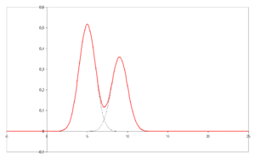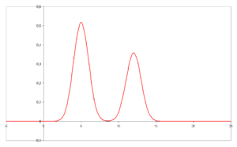
Plotted on the x-axis is the retention time and plotted on the y-axis a signal (for example obtained by UV spectroscopy) corresponding to the amount of analyte exiting the system.
- A chromatograph takes a chemical mixture carried by liquid or gas and separates it into its component parts as a result of differential distributions of the solutes as they flow around or over the stationary phase.
- Chromatography is a physical method of separation in which the components to be separated are distributed between two phases, one of which is stationary (stationary phase) while the other (the mobile phase) moves in a definite direction.
- The effluent is the mobile phase leaving the column.
- An immobilized phase is a stationary phase which is immobilized on the support particles, or on the inner wall of the column tubing.
- The mobile phase is the analyte and solvent mixture which travels through or along the the stationary phase, in a definite direction. It may be a liquid (LC), a gas (GC), or a supercritical fluid (supercritical-fluid chromatography).
- Preparative chromatography is used to nondestructively purify sufficient quantities of a substance for further use, rather than analysis.
- The retention time is the characteristic time it takes for a particular molecule to pass through the system under set conditions.
- The sample is the mixture consisting of a number of components the separation of which is attempted on the chromatographic system as they are carried or eluted by the mobile phase.
- The solute refers to the sample components in partition chromatography.
- The solvent refers to the liquid stationary phase in partition chromatography.
- The stationary phase is the substance which is fixed in place for the chromatography procedure and is the phase to which solvents and the analyte travels through or binds to. Examples include the silica layer in thin layer chromatography.
Chromatography theory
Chromatography is a separation method that exploits the differences in partitioning behavior between a mobile phase and a stationary phase to separate the components in a mixture. Components of a mixture may be interacting with the stationary phase based on charge, relative solubility or adsorption. There are two theories of chromatography, the plate and rate theories.

Retention

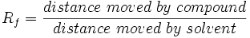

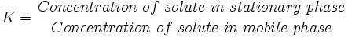

Techniques by physical state of mobile phase

Gas chromatography
Gas chromatography (GC) is a separation technique in which the mobile phase is a gas. Gas chromatography is always carried out in a column.
Gas chromatography (GC) is based on a partition equilibrium of analyte between a solid stationary phase and a mobile gas. The stationary phase is adhered to the inside of a small-diameter glass tube (a capillary column) or a solid matrix inside a larger metal tube (a packed column). It is widely used in analytical chemistry; though the high temperatures used in GC make it unsuitable for high molecular weight biopolymers, frequently encountered in biochemistry, it is well suited for use in the petrochemical, environmental monitoring, and industrial chemical fields. It is also used extensively in chemistry research.
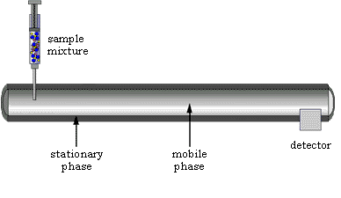sample mixture is injected into a long tube (the column)
mobile phase is an inert gas that sweeps the sample down the tube
stationary phase lining the tube selectively adsorbs or dissolves components
the stationary phase is a solid or very syrupy liquid silicone polymers (like Silly Putty!) are often used as stationary phases in gas chromatography

a detector responds to separated components as they leave the tube

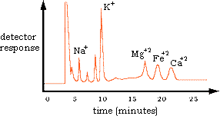

Liquid chromatography
Liquid chromatography (LC) is a separation technique in which the mobile phase is a liquid. Liquid chromatography can be carried out ieither in a column or a plane. Present day liquid chromatography generally utilizes very small particles and a relatively high pressure is characterized by high performance liquid chromatography (HPLC).
In the HPLC technique, the analyte is forced through a column (stationary phase) by a liquid (mobile phase) at high pressure, which decreases the time the separated components remain on the stationary phase and thus the time they have to diffuse within the column. Specific techniques which come under this broad heading are listed below. It should also be noted that the following techniques can also be considered fast protein liquid chromatography if no pressure is used to drive the mobile phase through the stationary phase. See also Aqueous Normal Phase Chromatography.
Chromatography according to the technique used
Column chromatography
Analyte, stationary phase, and mobile phase. The observer could represent the detector used in some forms of analytical chromatography. A key point is that the detector need not be capable of discriminating between the analytes, since they have become separated before passing the detector.
Chromatography may be preparative or analytical. Preparative chromatography seeks to separate the components of a mixture for further use (and is thus a form of purification). Analytical chromatography normally operates with smaller amounts of material and seeks to measure the relative proportions of analytes in a mixture. The two are not mutually exclusive.
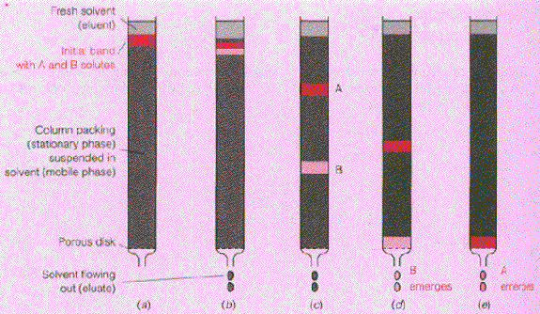

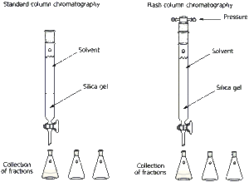

Planar Chromatography "Sheet chromatography"
Planer chromatography is a separation technique in which the stationary phase is present as or on a plane. The plane can be a paper, serving as such or impregnated by a substance as the stationary bed (paper chromatography) or a layer of solid particles spread on a support such as a glass plate (thin layer chromatography).

Thin layer chromatography
- thin layer chromatography (TLC)
  - stationary phase is a thin layer of adsorbent (Al₂O₃ or SiO₂, usually) coating a sheet of plastic or glass
  - some components bond to the adsorbent strongly; others, more weakly
  - as with paper chromatography, components appear as spots on the sheet
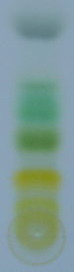
Thin layer chromatography is used to separate components of chlorophyll

Paper Chromatography
- paper chromatography (PC)
  - stationary phase is liquid soaked into a sheet or strip of paper
  - mobile phase is a liquid solvent
  - some components spend more time in the stationary phase than others
  - components appear as separate spots spread out on the paper after drying or "developing"

Technique
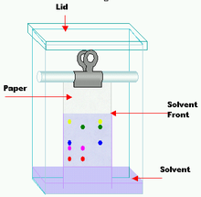
.

Techniques by separation mechanism

Ion exchange chromatography
Ion exchange chromatography is a column chromatography that uses a charged stationary phase. It is used to separate charged compounds including amino acids, peptides, and proteins. The stationary phase is usually an ion exchange resin that carries charged functional groups which interact with oppositely charged groups of the compound to be retained. Ion exchange chromatography is commonly used to purify proteins using FPLC.

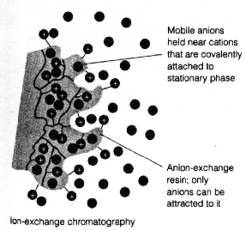

Size exclusion chromatography
Size exclusion chromatography (SEC) is also known as gel permeation chromatography or gel filtration chromatography and separates particles on the basis of size. Smaller molecules enter a porous media and take longer to exit the column, whereas larger particles leave the column earlier. It is generally a low resolution chromatography and thus it is often reserved for the final, "polishing" step of a purification. It is also useful for determining the tertiary structure and quaternary structure of purified proteins, especially since it can be carried out under native solution conditions.

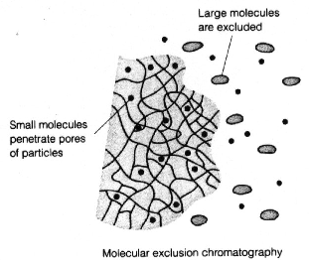

Adsorption Chromatography

Adsorption chromatography is probably one of the oldest types of chromatography around. It utilizes a mobile liquid or gaseous phase that is adsorbed onto the surface of a stationary solid phase. The equilibriation between the mobile and stationary phase accounts for the separation of different solutes.

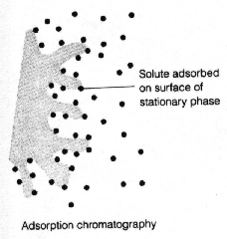

Partition Chromatography

This form of chromatography is based on a thin film formed on the surface of a solid support by a liquid stationary phase. Solute equilibriates between the mobile phase and the stationary liquid.

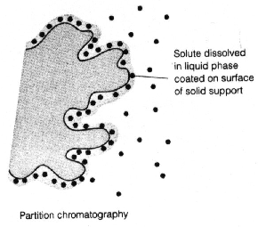

CAM
Complementary & Alternative Medicine
Orthodox Medicine (OM) = Modern Medical Treatment
- Complement: In Conjunction With OM
- Alternative: Used instead Of OM
Regulated By MOH in Western Countries or Industrial, In 3rd World or Developed Countries Rarely Regulated, Usually Practiced By Non-Professional without License

Reasons for Increase CAM Therapy?
- Dissatisfaction Of Pts With OM Especially Chronically Diseased Pts (Ca., CVS, Renal Dis., Diabetes)
- High Price Of Medicine
- In Developing Countries There Is No Access To OM
- WHO Role In Advertising & Encouraging Cam
  - Advances In Research V. Effective For Unknown Reasons
  - Treatment For Every Individual In The World Programmed

Life circumstances
↓
CAM
Life day maintain good health
↓
Prevention of disease
OM
↓
Treatment of health
↓
Cure

Criteria | CAM | OM
Time | More  “Works with body” | Less
Touch | Increase | Decrease
Hx-taking | Holistic, expansive | Sp. Behavior
Pt. Role | Conscious, participate | Passive
Decision making | Share with pts | Practitioner make decisions
Bedside manner  “Diagnosis” | Empathic, worm | Professional, cool
Language | Subjected,  Simple words | Objective, use jargon

Holistic approach: holistic principles that is common to all complementary disciplines. Each pt. Should be treated as complete individual, that means remedies (or procedure) for one pt. Might be totally inappropriate for another even though the symptoms may be similar conversely, the same remedy maybe used to treat very different condition in different pt

Classification
Based on the nature of the treatment u can classify them into:
- Complementary
- Alternative

1. Homeopathy
Greek Homosis = like, pathos = Treatment → Hahnemann (Germ. ph) 19th century
“Symptoms out cry of the body “
→Illness is an outward of body reflection of the body’s inner fight to overcome illness not a manifested of the illness its if …..

Def: Complement & Prevention
Administration Of Drug Of Ultra Diluted Medication Prepared According To Methods Specified by Various Homeopathic pharmacopeia to encourage innate power of the body to treat itself

Ex: Onion Peeling: "Allium Cepa"
Tears
Runny Nose
Redness in Face →Facial Skin
Principles:
1-like cure like:
→These Symptoms like Cold & Flue Symptoms→To Stimulate the Immune System
- We Use V. Diluted Conc. Of Substance
- All Homeopathy Drug Are Natural From Animal & Vegetable Sources
2- Single dose remedy

How Do We Prepare Drug?
1. Potentiation
Drug which is ultradiluted:
→Increase ability to cure
→Stimulate immune system
2. Mother Tincture (extract alc)[→onion + alc→M.T]
a.1C (1st centesimal potency) 1:100 = 1vol. of M.T→in 100 vol. solvent (alc)
b. Decimal dilution →1:10
D₂…………..D₃
D₂ = 1 drop 1C + a drop H₂O or alc
Material
- Glass packs (not aluminum never ever use)
- Best ware is clay then st.st.
- Short storing time (not more than 1yr)

C/I
  - No tea/coffee or any caffeine source herpes even green tea
  - No alc drink (interfere with drug)
  - Pregnancy & lactation no C/I v. rare vs. OM

  - Homeopathy when we consider as complementary or alternative?
1. Complementary→In Chronic Diseases except In Asthma & Lower Part of Digestive System
2. Alternative→ in Minor Diseases, Asthma, Allergenic Condition, & System (GI/Lower Part)

Aromatherapy
- Use as complementary not alternative
- Use fragrance of essential oil to effect or alter mode of person (cns)
- 6000yr old
Principle
Active Constituent Which Is Present In EO (essential oil) , Biochemistry Change In the following levels:
- Physiology
- Psychology
- Cellular
Mechanism
- Olfactory →Stimulate The Brain To Release Mediators
- Massage = Dermal Action →Increase The Permeability →Absorption By Improving The Circulation We Use EO Which Is Diluted With Inner Oil
Can't Be Use Directly Whether Olfactory or Dermal Since Its Toxic
Inner Oil (fixed oil):
- Sesame Oil (Not Olive Oil) 'Most Common"
- Sun Flour Oil
- Almond Oil (Sweat Almond Not Bitter)→V. Expensive

Most Use EO:
1.Lavender Oil For
a. Migraine by Both Means
- Olfactory
- Dermal
b. Cervical Muscular Spasm or Upper Back Pain→Dermal

2. Thyme & Chamomile →Both Ways for Symptomatic Prophylaxis of Motion Sickness "Use 30mint before Travel→Olfactory
3. Eucalyptol Oil Use
- Muscular Injuries: Dermal
- Flue & Cold: olfactory mainly.
C/I of Aromatherapy
Pregnancy & Lactation →some are teratogenic; must be used under medical supervision.
Application In:-
1. Cosmetic Industries
2. Treatment in OM Ex :
a. Clove Oil Symptomatic Treatment of Toothache "1 Drop in Tooth Not Gum"
B.Eucalyptus Oil →Topical Massage Preparation
C.Menthol →Vicks® / Mentholatus®
3. Toothpaste Industry
4. Food Industry

-Factors affecting dermal absorption of E.O

-Side effect of E.O

Reflexology

Complementary Type
- System We Use It To Diagnose Or Treat Minor ailement Or Disease Usually Pressure & Massage At Certain Points On The Foot Sole Or Hand Palm
- Done Using Diluted EO
- Rebalance Of Energy & Relief Pain
- Need At Least 4-5 Session.

Indian & Chinese System of Diagnosis of Treatment 3000 BC Used With Acupuncture
Principle
- Body Represent On Feet Sole (Mostly) & Hand palm.
- Involve Palpitation To Locate Sites Of Tenderness Or Crystalline Deposits Beneath The Skin Represent Organ Disease
  - 1 Session Twice A Week

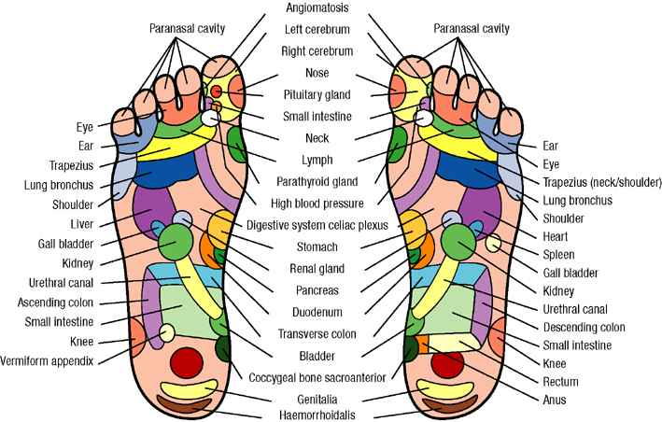

OSTEOPATHY & CHIROPRACTIC
- Diagnose & Treatment Of Pain & Dysfunction In The Muscle Skeletal System Due To Mechanical Problem
- Manipulation., Stretching
- Effective Increase Blood Flow To Nerve & Organs
Osteopathy:
Theory:
1-Body unity
2-Vital energy
3-Interrelationship between structure and function
4-Treatment depends on the previous three principles
  - Backache
  - Neck Pain
  - Sport Inj.
  - Repetitive Strain
  - Headache (Not Migraine)

Chiropractic: Especially Spinal cord

Chiropractic is a health care discipline and profession that emphasizes diagnosis, treatment and prevention of mechanical disorders of the musculoskeletal system, especially the spine, under the hypothesis that these disorders affect general health via the nervous system
31 pairs emitted from the spinal cord.

Reiki:
Is a Japanese technique for stress reduction and relaxation that also promotes healing. It is administered by "laying on hands" and is based on the idea that an unseen "life force energy" flows through us and is what causes us to be alive. If one's "life force energy" is low, then we are more likely to get sick or feel stress, and if it is high, we are more capable of being happy and healthy. The word Reiki is made of two Japanese words - Rei which means " the Higher Power" and Ki which is "life force energy". So Reiki is actually "spiritually guided life force energy."

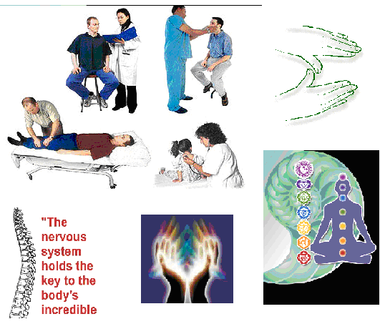

TCM=CTM
Chinese Traditional Medicine
Not CHM=Chinese Herbal Medicine
Energy Types

- Yin
- Yan
→In Balance If Not→Disease
Treatment the Body as a Unit & Not Disease
Ex:
- Acupuncture
- CHM
- Aromatherapy
CTM
System of Therapy Based On Healing the Body through Balance between Yin & Yang
Chinese
- Dental Pain Problem (Symptomatic Treatment)
- Psychology Problem
- Drug Dependence
C/I
- Pt Willing To Be Pierce & Trauma
- Pt High Risk Of Bleeding
- Pt. Pacemakers →Electric Stimulant
S.E
- Hepatitis
- HIV
- Trauma; Local Hematome Or Fatal If Affect The Heart
- Allergy Of Metal Needle (Chrome & Nickel) Best St. St
- Convulsion
- Cardiac Arrhythmia

Role of Pharmacist
- Sterility Of Needle:
- Resterilize→Autoclave
- Single Use Only
- No. Of Needle Must Be Counted 12→12 Pr-Po Session
- Lie Down During Treatment
- Rise Up Slowly At End Of Treatment
CHM
  - Fast Growing Industry In Western:
  - 1000yr BC Oldest
  - Alternative Type
Principle
- Balance Yin & Yang

Dispensing➔At CHM Pharmacy Not To Be With OM
- Main Ingredient→Treatment
- Associate Ing.→Assist
- Adjuvant→Enhancer
- guide ;Detoxifying Plant

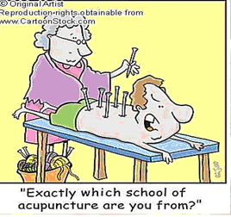

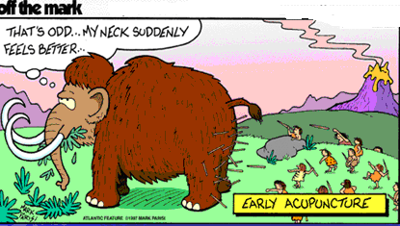

Naturopathy

(Also known as naturopathic medicine or natural medicine):

is an alternative medical system that focuses on natural remedies and the body's vital ability to heal and maintain itself. Naturopathic philosophy favors a holistic approach and minimal use of surgery and drugs. Naturopathy comprises many different treatment modalities of varying degrees of acceptance by the medical community; diet and lifestyle advice may be substantially similar to that offered by non-naturopaths

Principles
- First, do no harm; provide the most effective health care available with the least risk to patients at all times (primum non nocere).
- Recognize, respect and promote the self-healing power of nature inherent in each individual human being. (Vis medicatrix naturae, a form of vitalism).^{[32]}
- Identify and remove the causes of illness, rather than eliminate or suppress symptoms (Tolle Causum).
- Educate, inspire rational hope and encourage self-responsibility for health (Doctor as Teacher).
- Treat each person by considering all individual health factors and influences. (Treat the Whole Person).
- Emphasize the condition of health to promote well-being and to prevent diseases for the individual, each community and our world. (Health Promotion, the Best Prevention)
Detoxification (detox for short):
is the physiological or medicinal removal of toxic substances from a living organism, including, but not limited to, the human body and additionally can refer to the period of withdrawal during which an organism returns to homeostasis after long-term use of an addictive substance.^{[2][3]} In conventional medicine, detoxification can be achieved by decontamination of poison ingestion and the use of antidotes as well as techniques such as dialysis and (in a very limited number of cases) chelation therapy.^{[4]}

Auyverdic Medicine
(Indian Medicine)
Auy: Longevity or life.
Verda: Treatment or Knowledge
Principle
They Look At Disease as Imbalance between Body & Environment
Treatment →to Reestablish Balance between Body & Environment
- 8 main Specialty in Indian medicine:

1- Medicine.
2- Fertility and sterility
3- Gynecology.
4- Geriatric and pediatrics.
5- Psychology.
6- Surgery
7- Toxicology
8- Nose, ear and throat.

Uses for Treatment
- Use Plant For Treatment
- Exercise
- Meditation
- Animal product.
- Precious and semiprecious metals.
- colour therapy
- massage.
- minerals.

→Effective in much Disease with Statistical Research on Treatment
S.E or Precaution
- Poisoning By Mercury & Heavy Metal
- Contaminate With It & Depend On Mineral
Disease
  - GIT Disease
  - As Tonics →Ginseng
  - Female Disease

Persian & Islamic Herbal Medicine
    - No Enough Reliable Written Document & References
    - No Consistency In Use
Islamic → Nabawi Medicine
- No Paint
- No Document
- Lack Of Money
- Political

Summary
CAM | Mechanism Or Principle or Aim Or theory
Homeopathy  Qualification  Time:  Homosis=Like & Pathy=disease or suffering  Complementary displine based on law of similar which involves administration of ultra dilute medicines prepared according to the methods specified in various homeopathy pharmacopoeia with the | Mechanism: weak stimuli encourage living system →small Qyt. Of Hp medicine administered to an individual stimulate body’s own defense mechanism to deal with disease  Aim: of stimulating a person’s own capacity to heal  Theory: Hp. Consider disease to be an expression of vital force of each individual  Principle:  - Like cure like  - Minimal dose  - Single remedy  Like cure like→in order to cure disease, one must seek medicines that can excite similar symptoms in healthy human body  Minimal dose: clinical experience suggests that the minute amount of a.c administrated by hp are still sufficient to reduce a therapeutic effect it’s generally accepted that the frequency of administration is more significant than the size of dose
Aromatherapy Alternative; use fragrance of essential oil to effect or alter mode of persons (CNS) | Theory: the basis of action →is similar to ph.cology with active principle entering the biochemical p.w, albeit in much small doses →work at psychological, physiological & cellular level  2 mechanism:  Olfactory: stimulant enter nose reaching olfactory bulb from here nerve impulses move on to limbic system of brain where area of amygdala & hippocampus are associated with emotional & learning process respectively, learning process though to be responsible for memories evoked by various different odors  Dermal action: direct physiological action on body, with active component being absorbed into bleed stream through the skin absorption enhanced by warming skin or massage
Osteopathy:  Osteon + pathos = suffering of bones  Is medical discipline that based on primary on the manual diagnosis & treatment of impaired function resulting from loss of movement  Its philosophy have emphasis on internal relationships of structure & function, with an appreciation of body’s ability to heal itself .it use wide range of technique to treat musculoskeletal problem & other function disorder of body | Technique:  Purely & solely based on manual tech., Which are used to adjust & correct mechanical problem in whole body. No prescription no invasive technique.  Aim: to stimulate the pt’s natural healing process
Reflexology  Reflexology = reflex in this case meaning one part reflecting another part & ology= study of ➔the study of how one part reflect another  Its scientific theory that maps out the reflexes on the feet & hands to ll organs & rest of body. it involve application of pressure to reflex areas of hand or feet to produce effect in other part of the body | Theory when reflex are stimulated the body’s natural electric energy work along the nervous system & meridian lines to clear any blockages on those lines & in corresponding zone. A treatment seem to break up deposit felt as gritty area under skin) that may interfere with natural flow of the body’s energy

Cam Therapy | Mechanism Or Principle
CTM Or TCM  TCM= is generic term used to describe no, of medical practice the originated in china it include; acupuncture, chm, meditation, mind & body exercise | Yin & yang: the world & all life within it comprise pairs of opposites each giving meaning to other, the relationship between 2 elements is dynamic.  Yang: s positive state associated with heat, light & vigor  Yin: is negative state associated with cold, dark, stillness & passiveness  Only when opposite are in equal balance is life in harmony too much or too little of either element result in disharmony →treatment would therefore be seen as the ability to promote the conversion of excess yang into yin, allowing restoration of equilibrium between e2 element  5 organ→heart, lungs, liver, spleen, kidneys  Meridians: they are channels that carry qi & blood through the body they form an invisible network close to surface of body which link together all fundamental features & organs, they are essential for maintenance of harmonious balance & a loge of meridian no.  Of point used by acupuncturist.  Disease →internal imbalance between yin & yang due to external factors
Acupuncture:  Complentary Acus = needle, puntur=pierce  Introduce certain needle which are very fine & long in certain point in body called meridian path it represent certain path of energy | Same as CTM
CHM | Like TCM based on concepts of yin & yang & of qi energy. The herbs ascribed qi such as cooling (yin) &, stimulating  (Yang) according to deficiencies or excess of these Q in pt.

