Designing a CV using MS Word 2010 Templates
Microsoft Word 2010: Is a program used to edit documents, letters, researches and any kind of documents you may need.
It is a part of Microsoft Office, which is a full package concerned with Office needs.
Word Templates: a template in Word is a ready-made document, designed for a certain purpose, where you can use the template, update it a little to accomplish your needs.
How to download a template?
- Open MS Word.
- From “File” tab, go to “New”
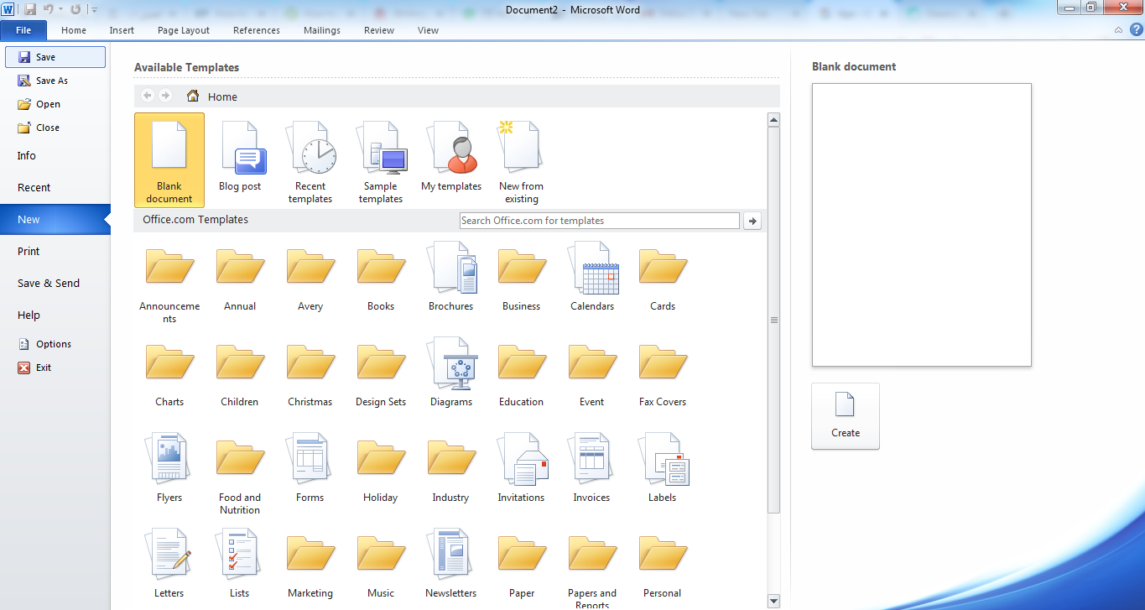
In this window, you can find several categories of available templates. Such as: Brochures, Forms, Flyers, …etc.
- Use the search box, to search for CV templates. Just write “CV”, and press the arrow button.
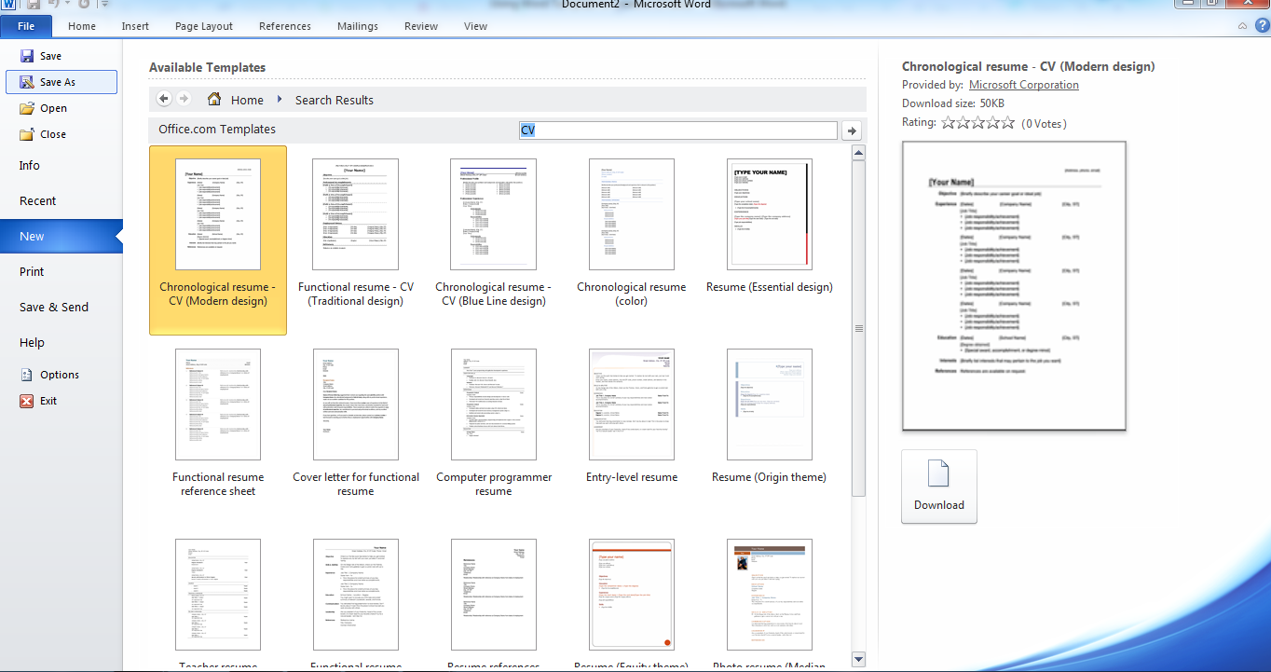
Several designs and types of CV templates will appear.
- At the right of the screen, you will find an image displaying the design of any selected template, you can depend on it when selecting the design you like most.
- Select the design you want, and press the “Download” button.
- The following is an example of a template. Each [ ] contains a description of the information that you can add. Add the information, but of course don’t forget to delete the [ ].

Example of a Template:
[Address, phone, email]
[Your Name]
Objective | [Briefly describe your career goal or ideal job]
Experience | [Dates] |  | [Company Name] | [City, ST]

[Job Title]
- [Job responsibility/achievement]
- [Job responsibility/achievement]
- [Job responsibility/achievement]
 | [Dates] | [Company Name] |  | [City, ST]

[Job Title]
- [Job responsibility/achievement]
- [Job responsibility/achievement]
- [Job responsibility/achievement]
 | [Dates] | [Company Name] |  | [City, ST]

[Job Title]
- [Job responsibility/achievement]
- [Job responsibility/achievement]
- [Job responsibility/achievement]
 | [Dates] | [Company Name] |  | [City, ST]

[Job Title]
- [Job responsibility/achievement]
- [Job responsibility/achievement]
- [Job responsibility/achievement]
Education | [Dates] | [School Name] |  | [City, ST]

[Degree obtained]
- [Special award, accomplishment, or degree minor]
Interests | [Briefly list interests that may pertain to the job you want]
References | References are available on request.

- Using such template will save time and effort, so that you just fill the information, while the document is designed and the sections are listed ready to be filled.
- Of course you can remove or add any information.
- For example: you don’t want to add “Interests”, you can simple remove this part.
- If you like to add a new part for example, volunteer work, you can add it with the same format, or replace an existing part that you want to remove.

Online Templates
Microsoft provides you with additional Word templates that can be either downloaded for free, or bought.

Visit www.microsoft.com, search for “Word CV Templates”, and you can find links to guide you to other templates on line.

Examples of Good and Bad CVs
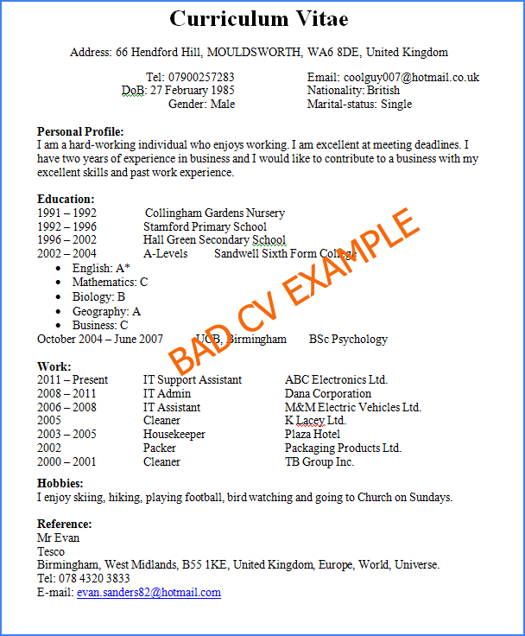
Try to find the mistakes done in this CV.

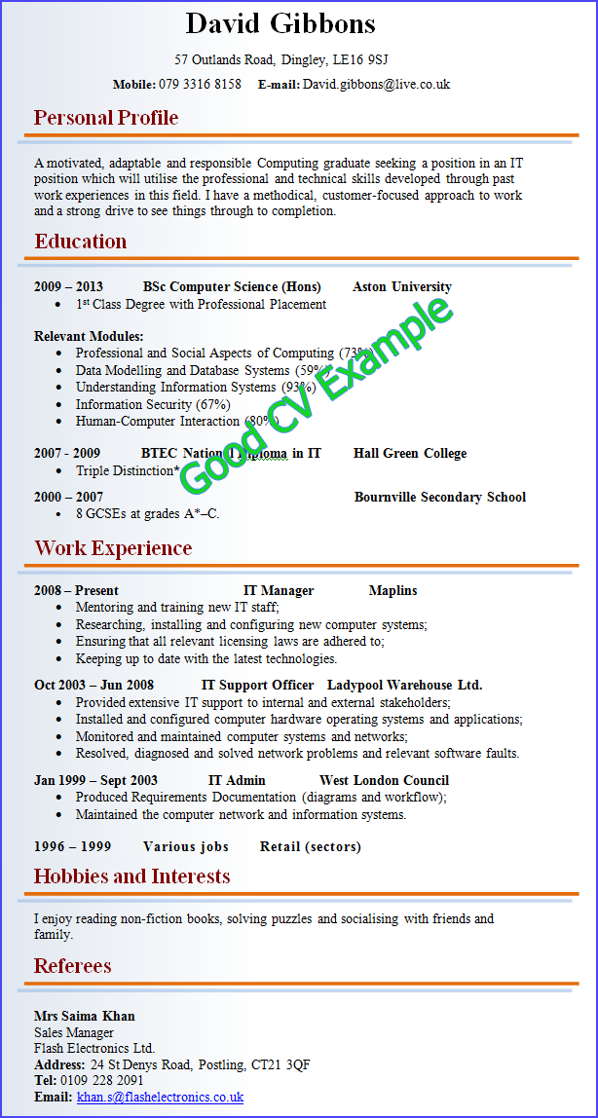
Exercise

Use a ready Word Template and write your CV using the tips given in previous lectures.
You are also requested to add a cover letter at the beginning.

