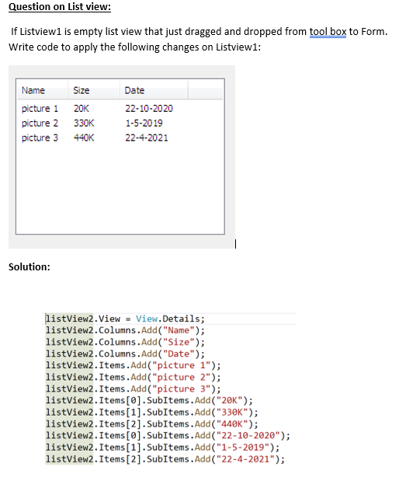

MessageBox.Show( listView1.Items.Count.ToString());

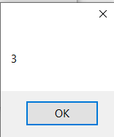

If you select first item after write the foolowing event handler:

private void listView2_ItemSelectionChanged(object sender, ListViewItemSelectionChangedEventArgs e)

{

MessageBox.Show(e.Item.ToString());

}

The result is:

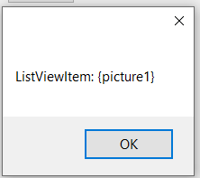

To delete all items and subitems in above listview:

listView2.items.Clear();

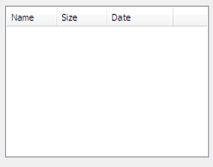

To delete all items and subitems **and columns** in above listview:

listView2.Clear();

