Philadelphia University |  |  | Faculty of information Technology
Coordinator: Mrs. Eman Alnaji |  |  | Department of Computer Science
Internal Examiner: Dr. Hasan Al Refai |  |  | Examination Paper
Computer Skills (9761111)  Computer Skills – Humanities (0710103) | Final Exam |  | First Semester of Academic Year 2014/2015
Date: 10 February 2015 |  |  | Time: 2 Hours A
Student No.: ...................................... Student Name: .............................................................
Lecturer: .......................................... Section No.: ..................................................................

Information for candidates
- This examination paper contains 40 questions, totaling 40 marks
- Marks of Each Question is 1.

Advice to Candidates
1. You should attempt all questions.
2. You should write your Answers clearly in the specified place in the first page.

Question | Answer | Question | Answer
1 |  | 21
2 |  | 22
3 |  | 23
4 |  | 24
5 |  | 25
6 |  | 26
7 |  | 27
8 |  | 28
9 |  | 29
10 |  | 30
11 |  | 31
12 |  | 32
13 |  | 33
14 |  | 34
15 |  | 35
16 |  | 36
17 |  | 37
18 |  | 38
19 |  | 39
20 |  | 40

I) Front Page

Q1: One of the following will only appear in the design view of a webpage:
- Comments
- Hotspots
- Data and time
- None of the above

Q2: The Way of viewing the following Web page is called:
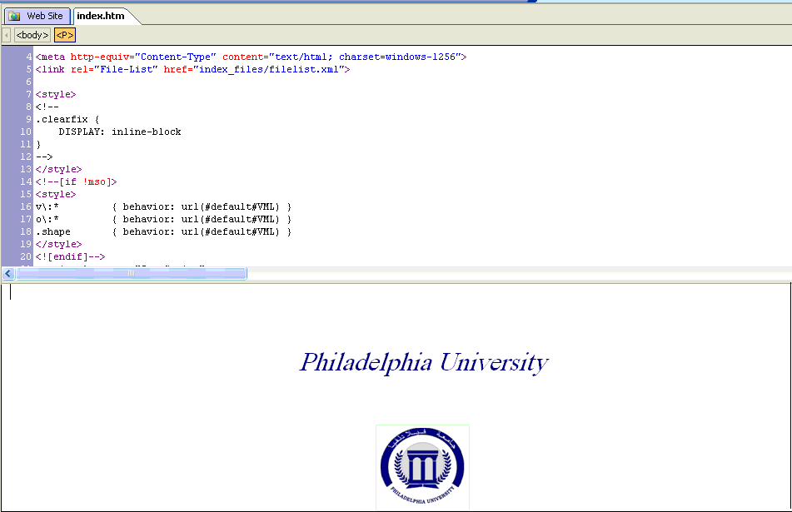
- Design View
- Split View
- Code View
- Preview View

Q3: The name of the following created Web site is:

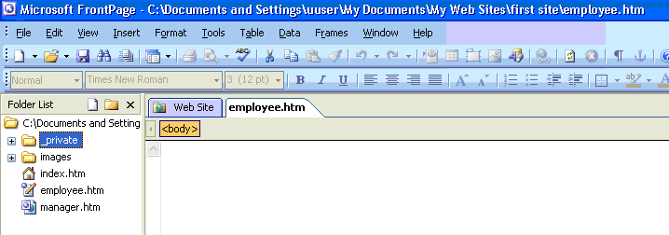

- Index
- employee.htm
- first site
- My Web Sites

Q4: If the following properties applied to a video clip, then the number of times the video will play is:

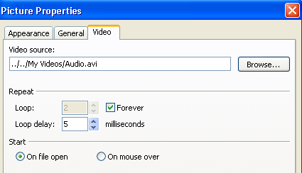

- 1 time
- 5 times
- 2 times
- Continuously (without stopping)

Q5: Depending on the following Insert Hyperlink dialog box, the link will be used to transfer (ينقل) the user to:

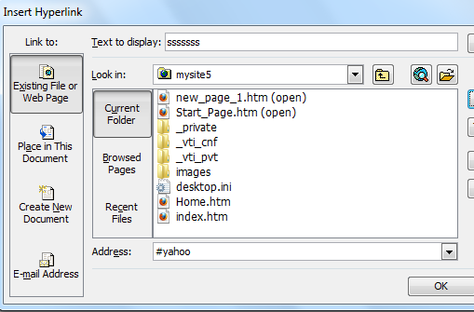

- Web site called yahoo
- Word document called yahoo
- Bookmark called yahoo
- Web page called yahoo

Q6: To add unavailable (غير متوفر) commands to a menu, do the following:
- Tools menu ➔Customize
- Insert menu ➔ Web component
- View menu ➔ Reveal Tags
- Insert menu ➔ Form

Q7: The number of paragraphs in the following web page is:

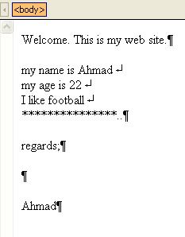

- 3
- 4
- 5
- 8

Q8: Depending on the following Insert Hyperlink dialog box, the text that will be used as a link in the web page is:

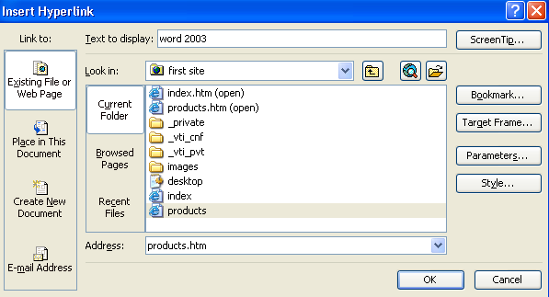

- Bookmark
- word 2003
- first site
- products.htm

Q9: To create hotspots on any picture inserted to a Web page, you cannot use icon with number:

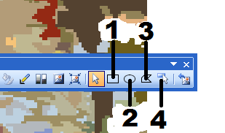

- 1
- 2
- 3
- 4

Q10: One of the following is correct about any Banner Ad Manager:

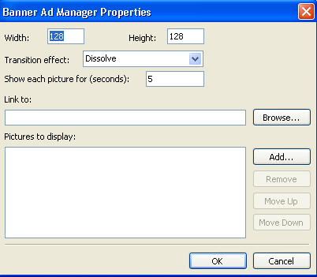

- You can add only one picture to the banner
- You can add a hyperlink to the banner
- The order of the pictures cannot be changed
- The size of the banner cannot be changed

Q11: The style which has the largest font size is:

- Heading1
- Heading3
- Heading6
- All heading styles have the same font size

Q12: In Front Page, which of the following should be the name of the home page of any site?

- Index.htm
- Home.htm
- First.htm
- Any of the above is correct

Q13: Based on the following photo gallery properties, number of pictures that will appear in each row when you choose Horizontal layout is:

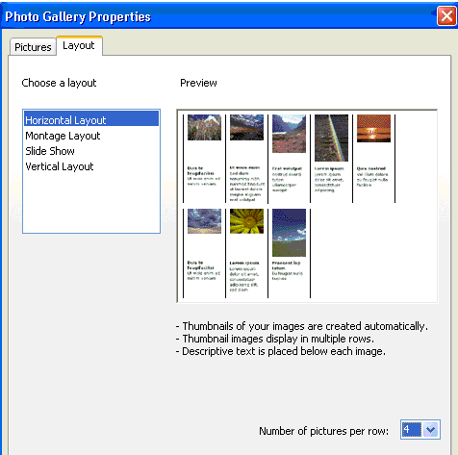
- 5
- 8
- 4
- Unknown

Q14: Which of the following cannot be a hyperlink?
- Text
- Hover Button
- Picture
- None of the above

Q15: One of the following cannot be added to your Web page if you have already applied “Theme” to it:
- Date and Time
- Hover button
- Marquee
- Background

Q16: The title of the following Web page is:
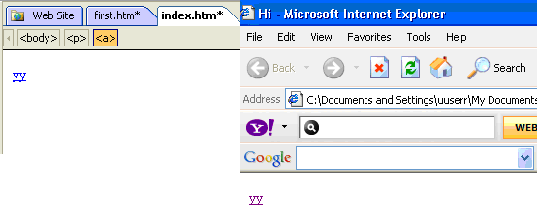
- index
- Microsoft Internet Explorer
- Hi
- yy

Q17: In front page, the theme consists of:
- Font color.
- Hyperlink color and effects.
- Background color and images.
- All of the above.

Q18: To move to a different part of the same web page, we use:
  - Hyperlink to a bookmark.
  - Hyperlink to another page.
  - Hyperlink to an email.
  - Hyperlink to an image.

Q19: In front page, to keep track of and display the number of times your specific page has been viewed, you use:
- Search button.
- Banner ad manager.
- Hit counter.
- None of the above.

Q20: Which of the following is true about search button?
  - Search button works after the website is published.
  - Search button works offline.
  - Search button accepts English language only.
  - All of the above

II) Access

Q21: In the picture below, the button numbered by 1 is used to:

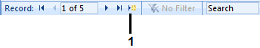

- Move to last record
- Move to next record
- Add a new record
- Move to first record

Q22: Changes applied on Table fields in the design view:
- Are saved automatically by Ms Access 2007
- Should be saved by the user.
- Cannot be changed later on
- All of the above.

Q23: In Access, a row in a table is called:
- Record
- Field
- Cell
- Row

Q24: A primary key field:
- Should not contain null values.
- Should not contain redundant (مكررة) values.
- Its data type should be number
- A and B.

Q25: In the picture below, total number of fields in the displayed employees table is:

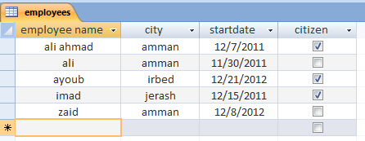

- 6
- 4
- 3
- 5

Q26: In the picture below, number of created queries in the displayed database is:

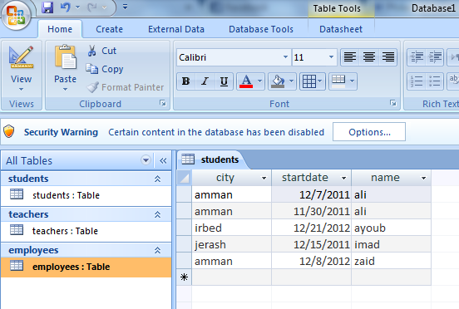

- 1
- 6
- 3
- Unknown

Q27: In the picture below, the result of total function in the displayed query is:

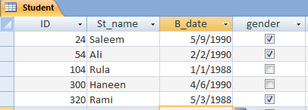
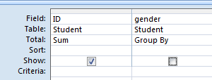

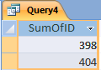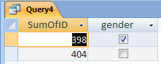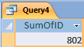
Query1 Query2 Query3

- Query1
- Query2
- Query3
- None of them

Q28: The icon which is used to add a field from a table in the design view is:

Q29: In the picture below, which of the following records is found in the datasheet view, when running the displayed query?
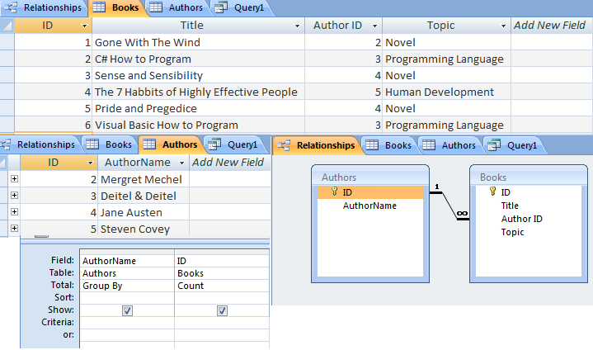

- Deitel & Deitel, 3
- Jane Austen, 2
- Mergret Mechel, 0
- Steven Covey, 4

Q30: Which of the following data types accepts up to 250 characters?
- Date/Time
- Text
- Number
- Currency

II) Excel

Q31: In the picture below; the cell reference of the selected cells is:

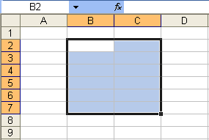

- B2:B7
- 7B:7C
- B7:C7
- B2:C7

Q32: Which of the following is an example of a correctly written Excel formula?
- =SUM(B1:B4)
- (B1:B4)
- B5 = SUM(B1+B4)
- SUM=(B1..B4)

Q33: In the picture below; the result of the formula =IF(OR(A2="Fadi",B2<50),PROPER("welcome"),"bad") is:
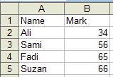
- Welcome
- bad
- TRUE
- WELCOME

Q34: In the picture below; the result of the formula =SUMIF(A3:A16,"Aqaba",C3:C16)+SUMIF(A3:A16,"Irbid",C3:C16)
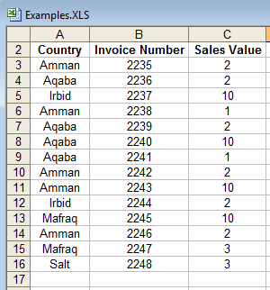
- 15
- 12
- 27
- 54

Q35: In the picture below; the formula which has the result "A" is:
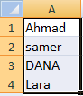
- =LEFT(UPPER(A4),2)
- =MID(A3,2,1)
- =RIGHT(A4,1)
- All of the above

Q36: In the picture below; number of created sheets in the displayed workbook is:

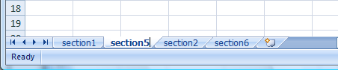

- 5
- 1
- 3
- 4

Q37: In the picture below, when applying the following formula on the displayed table,
=IF(OR(COUNT(C3:C5) > 30,TRUE),COUNT(A3:A5),10), the result should be:

- 0
- 3
- 10
- True

Q38: The result of the formula =MID(RIGHT(LEFT("this is my first exam", 21), 21),1,21) is:
- this is my first exam
- this is my
- this is
- this is my first

Q39: In the picture below; the format of cell A4 after applying the conditional formatting is:

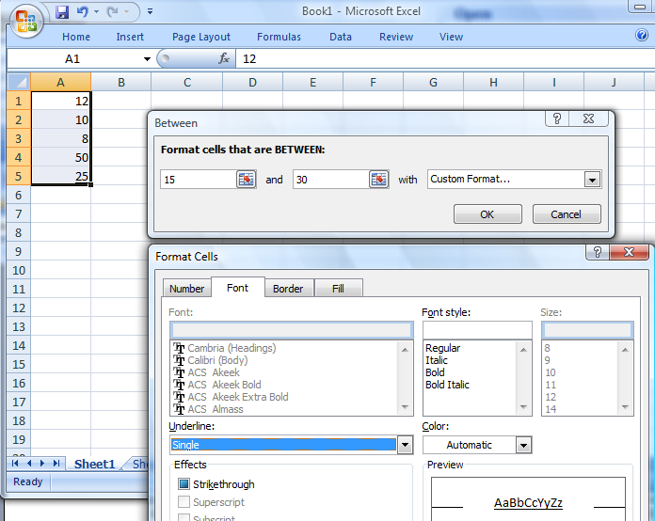

- Dotted (نقطي) border
- Bold
- Single Underline
- No format

Q40: In the picture below; if you format (Y) Axis of “The Original Chart” according to the displayed Format Axis dialog box, then the chart will look like the one which has number:

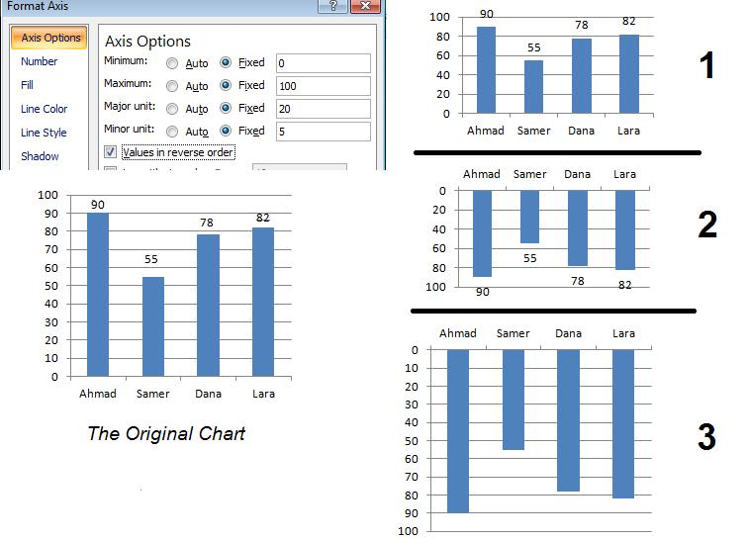
- 1
- 2
- 3
- None of the above

Good Luck
☺

