Philadelphia University
Faculty of Information Technology
Department of Applied Computer Science
Examination Paper
Lecturer: All Sections
Coordinator: Miss. Hanan Hardan
Internal Examiner: Dr. S. Ghoul

Programming Fundamentals(1) (750113) First Exam 2nd Semester of 2013/2014
Date:26/3/2014 Time: 50 minutes

Information for Candidates
- This examination paper contains 3questions, totaling 15 marks.
- The marks for parts of questions are shown in round brackets.

Advice to Candidates
1. You should attempt all questions.
2. You should write your answers clearly.

I. Basic Notation
Objectives: The aim of the question is to evaluate your basic knowledge of the key aspects of the lectures material and your ability to solve familiar problems.

Question 1 [5 Marks ]
Consider the following equations:
price = item_cost – Discount, item_cost = no_of_items*quantity, Discount = item_cost * 0.10
Draw a flowchart and write a pseudo code to compute the price and print it.

II. Familiar Problems Solving
Objectives. The aim of the questions in this part is to evaluate the required minimal student knowledge and skills. Answers in the pass category represent the minimum acceptable standard
Question 2 [6Marks ]
Given the following algorithm
Algorithm Test
Begin
//Data definition
w ,z ,h are logic
a ,b ,c ,d are numbers
a ← 20
b← 10
c← 5
d← a+b*c mod 2
output ”See carefully”

if(a>d) then
a ← a*10
w← ((a>b)and(c<d))
output ”a=”, a , endl
output ”w=”, w, endl
end if

output ”Check your mined ” , endl

if(c<d) then
b→b*5;
z→((a<c) or (c<=b))
output ”b=”, b, endl
output ”z=”, z, endl

end if

output ”the end \n”

End Test

- Trace the algorithm and find the output (3 marks)
- Translate the algorithm into c++ program (3 marks)

II. Unfamiliar Problem Solving
Objectives: to examine your ability to solve a problem that hasn't been discussed in class room.
Question 3 [4 Marks ]
a. .What is the output of algorithm? (1marks)
b. Write the equivalent c++ for the following Flowchart (3marks)

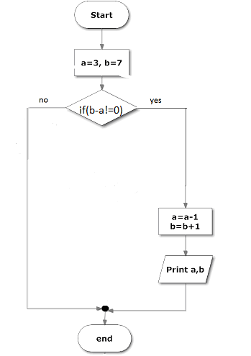

Good luck

