Philadelphia University
Faculty of Information Technology
First Examination Paper
Lecturer : Dr. Maram Bani Younes
Coordinator : Dr. Maram Bani Younes.
Internal Examiner:

Concurrent and Distributed Programming First Exam 2st. Semester of academic year 2014-2015 Section: 1 Date: 1/04/2015 Time: 50 Mins

Information for Candidates
- This examination paper contains 6 questions.
- The marks for parts of questions are shown in round brackets.

I. Basic Notions
Objectives: The aim of these questions is to evaluate your knowledge and skills concerning with the basic concepts of concurrent programming
.
- What is the difference between multi-tasking and multithreading concepts? (2 Marks)

- What is the difference between multi-tasking and multi-processor systems?(2 Marks)

- Mention the most important two tools of concurrent abstraction?(2 Marks)

II. Familiar Questions
Objectives: The aim of these questions is to evaluate you knowledge about the scenario and state diagram representations.

- For the following figure draw the scenario table of the following program using the scenario:
p1, p2, q1, p3, q2, q3. (5 Marks)
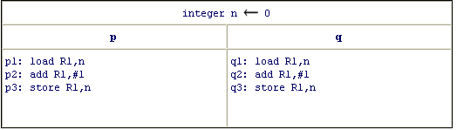

- Draw the state diagram of the following program: (5 Marks)
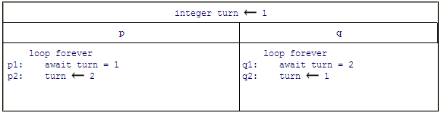

III- unfamiliar:
Objectives: the aim of this part is evaluate your understanding of the critical section correctness.

- Give an Example of Mutual Exclusion Scenario, Deadlock Free Scenario and two Starvation Processes, from the following two sequence figures of the critical section (4 Marks)
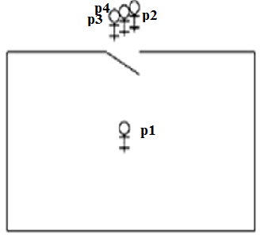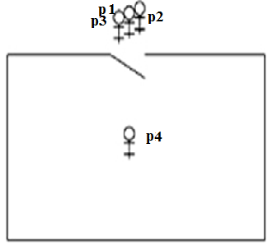

Good Luck!!!

