Example #1: //COUNT
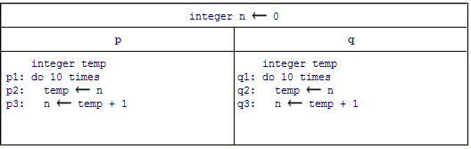
import java.lang.*;
class Count extends Thread {
static volatile int n = 0;
public void run() {
int temp;
for (int i = 0; i < 10; i++) { temp = n; n = temp + 1; }
}
public static void main(String[] args) {
Count p = new Count();
Count q = new Count();
p.start();
q.start();
try { p.join(); q.join(); }
catch (InterruptedException e) { }
System.out.println("The value of n is " + n);
}
}
Example # 2: Write A and B using two different classes
P | q
P1: do 10 times  P2: print “A” | q1: do 10 times  q2: print “B”

// A, B 10 times
import java.lang.*;
class CLASS1 extends Thread
{ public CLASS1 ()
{ }
public void run()
{
for(int i=0; i<10; i++){
System.out.print("A");
try{ Thread.sleep(300); }
catch(InterruptedException ie){}
}
}
}
class CLASS2 extends Thread
{
public CLASS2 ()
{ }

public void run()
{
for(int i=0; i<10; i++){
System.out.print("B");
try{ Thread.sleep(6); }
catch(InterruptedException ie){}
}
}
}
public class test
{ public test()
{ }
public static void main(String[] sCommand)
{
test app=new test();
CLASS1 T1= new CLASS1();
CLASS2 T2= new CLASS2();
T1.start();
T2.start();
}
}

------------------------------------------------------------------------------------------------------------------------
HW#1 Deadline: 13-11-2016 Email: mbaniyounes@philadelphia.edu.jo
-------------------------------------------------------------------------------------------------------------------------
Write the java code of the following two concurrent programming.
