Philadelphia University
Faculty of Information Technology
Second Examination Paper
Lecturer : Dr. Maram Bani Younes
Coordinator : Dr. Maram Bani Younes.
Internal Examiner: Dr. Raed Fadhil
Concurrent and Distributed Programming Second Exam 2st. Semester of academic year 2014-2015 Section: 1 Date: 06/05/2015 Time: 50 Mins
Information for Candidates
- This examination paper contains 7 questions.
- The marks for parts of questions are shown in round brackets.

I. Basic Notions
Objectives: The aim of these questions is to evaluate your knowledge and skills concerning with the basic concepts of concurrent programming
1- How can we prove the correctness of any critical section solution? (1.5 Marks)

- Write the details of the “compare-and-swap (common, old, new)” function? (2.5 Marks)

- What is the main difference between semaphores and monitors? and what is the main usage of them? (2 Marks)

II. Familiar Questions
Objectives: The aim of these questions is to evaluate you knowledge about critical section solutions
- Write the pre-protocol and the post-protocol commands using the “exchange” function, to solve the critical section problem in the following figure? (3 Marks)
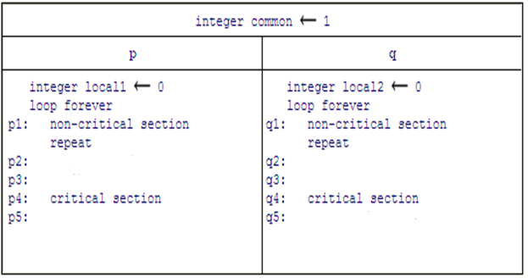

- What are the possible outputs of the following algorithm? (3 Marks)
semaphore S1 ← 1, S2 ← 0, S3← 0
P | Q | R
p1: write("pure ")  p2: signal(S1)  p3: signal(S2) | q1: wait(S1)  q2: write("quite ")  q3: wait(S3) | r1: wait(S2)  r2: write("rug ")  r3:signal(S3)

III- unfamiliar:
Objectives: the aim of this part is evaluate your understanding of the semaphore usage
- Use the defined semaphores to solve the consumer producer problem with bounded buffer in the following figure. (4 Marks). 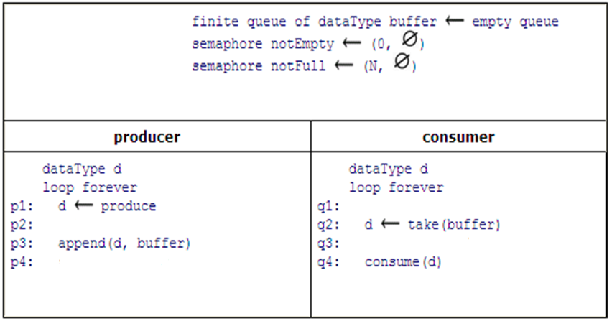

- Use the “wait” and “signal” functions of the defined semaphores in the following figure to obtain the result “Good Luck Guys ”. (4 Marks)
semaphore S1 ← 1, S2 ← 0, S3← 0
P | Q | R
p1:  p2: write("Guys")  p3: | q1:  q2: write("Good ")  q3: | r1:  r2: write("Luck ")  r3:

