Philadelphia University
Faculty of Information Technology
Second Examination Paper
Lecturer : Dr. Maram Bani Younes
Coordinator : Dr. Maram Bani Younes.
Internal Examiner: Dr. Hassan Al Refai

Wireless and Mobile Networks Second Exam 2st. Semester of academic year 2014-2015 Section: 1 Date: 07/05/2015 Time: 50 Mins

Information for Candidates
- This examination paper contains 6 questions.
- The marks for parts of questions are shown in round brackets.

I. Basic Notions
Objectives: the aim of these questions is to evaluate your knowledge concerning with the basic concepts of Wireless LAN networks
.
Q1: What is the difference between WLAN router and an access point? (2 Marks)

Q2: What are WLAN bridges? And what are their benefits? (2 Marks)

II. Familiar Questions
Objectives: The aim of these questions is to evaluate you knowledge about the familiar issues in the Wireless LAN network .
Q3: What are the main differences between the Infrastructure based and the infrastructure-less architecture modes of WLANs? Support your answer by graphs? (3 Marks)

Q4: What is the fundamental access method of 802.11? Explain this method principle and how is it different than CSMA\CD? (Note: Spell the words Abbreviation is not enough)
(3 Marks)

III- unfamiliar:
Objectives: the aim of this part is evaluate your understanding of WiMAX Network.

Q5: In following figure, what does each field determine? (4 Marks)

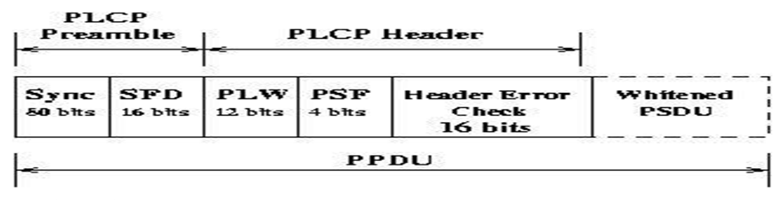

Q6: What are the main functionalities of each sublayer in the MAC Layer of IEEE 802.16?
(6 Marks)
- MAC Convergence Sublayer:

- MAC Common Part Sublayer:

- MAC Security Sublayer:

Good Luck!!!

