Philadelphia University
Faculty of Information Technology
Department of Software Engineering
Examination Paper
Lecturers Dr. Mohammad Taye
Coordinator Dr. Mohammad Taye
Internal Examiner: Dr. Maouche Mourad

Software Production (0721330) Second Exam 1st Semester 2014/2015
Date: 31/12/2014 Time: 50 min.

Information for Candidates
This examination paper contains 6 questions totaling 22marks.
Advice to Candidates
You should attempt ALL requested parts.
I. Basic notions. The aim of the question in this part is to evaluate the required minimal student knowledge and skills. Answers in the pass category represent the minimum acceptable standard

Question 1: (10 marks)
- What is the Agile software development? [2 mark]
Answer: Agile software development is a group of software development methods based on iterative and incremental development, where requirements and solutions evolve through collaboration between self-organizing, cross-functional teams.

- Mention four of Agility Principles (4 marks)
1. the highest priority is to satisfy the customer  2. Welcome changing requirements, even late in development.  3. Deliver working software frequently.  4. Business people and developers must work together daily throughout the project.  5. Build projects around motivated individuals.  6. face–to–face conversation. | 7. Working software is the primary measure of progress.  8. Agile processes promote sustainable development.  9. Continuous attention to technical excellence and good design enhances agility.  10. Simplicity is essential.  11. The best architectures, requirements, and designs emerge from self–organizing teams.  12. At regular intervals, the team reflects on how to become more effective, then tunes and adjusts its behavior accordingly.

- Mention and discuss four differences between agile and non-agile software development approaches. (4 marks)
Agile software development approaches | Non-agile software development approaches
lightweight processes | heavyweight processes
adaptive methods | predictive methods ( Structured)
code-oriented objectives | document-oriented objectives
incremental and iterative approach | linear model of software design (Waterfall)
very easy to response to change | very difficult to response to change
Customer feedback
Cost of change

Question 2: (5 marks)

- Discuss the Dynamic Systems Development Method (DSDM) lifecycle (4 marks)
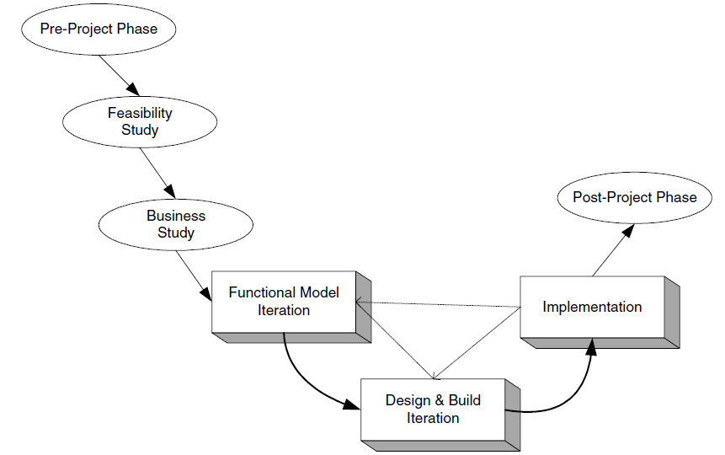

- What are the roles of Ambassador (in DSDM)? (1 marks)
They promote two-way communication and compromise between the end user community and the project development team.

II. Familiar problems solving: the aim of the questions in this part is to evaluate that the student has some basic knowledge of the key aspects of the lecture material and can attempt to solve familiar problems in software production.

Question 4: (5 marks) consider the following case study

A public library is considering the implementation of a computer-based system to help administer book loans at library. The actors of this system are:
Customer: Customers of a library can apply for a library membership. Then, they can search for books and borrow them. They have to return the borrowed books according to specific loan periods.
Librarian: Librarians manage the book stock in the library. They register new customers in the library application. They enter the loan of a book by a customer in the system. Books that are overdue result in a reminding process. The librarian manages this process.
Accountant: Registration and reminding fees are to be paid by customers. Accountants deal with those payments with a separate accounting application.

(Draw a lifecycle graph).3 marks
