|  |  |  |  |
| --- | --- | --- | --- |
| QFO-AP-VA-008 | **رمز النموذج :** | **اسم النموذج :** خطة تدريس مادة دراسية | **جامعة فيلادلفيا**  Philadelphia University |
| 1 | **رقم الإصدار: (Revision)** | **الجهة المصدرة:**  نائب الرئيس للشؤون الأكاديمية |
| 7-3-2019 | **تاريخ الإصدار:** | **الجهة المدققة :** اللجنة العليا لضمان الجودة |
| 1 | **عدد صفحات النموذج :** |

**Faculty of Arts**

**Department of English Language and Literature**

**First Semester, 2020/ 21**

|  |  |
| --- | --- |
| **Course Syllabus** | |
| 0120251 | | Introduction to Literature | |
| 120221 | | Second year | |
| 3 | | **:** 8.10- 9.00 | |

|  |  |  |  |  |
| --- | --- | --- | --- | --- |
| **Academic Staff Specifics** | | | | |
| **E-mail Address** | **Office Hours** | **Office** | **Rank** | **Name** |
| nhamdi@philadelphia.edu.jo | Sun, Tue, Thu: 9.00- 10.00; Mon, Wed:9.45- 11.00 | Click or tap here to enter text. | Choose an item. | Nadia Hamdi |

**[**

|  |  |
| --- | --- |
| **Date** | **Topic** |
| WEEK 1 | Introduction  What is literature  What is poetry |
| WEEK 2 | There is no Frigate like a book |
| WEEK 3 | Sonnet 18 |
| WEEK 4 | Red Rose |
| WEEK 5 | Meeting at night, parting at morning  Mending Wall |
| WEEK 6 | Sonnet 130 |
| WEEK 7 | Plot |
| WEEK 8 | Character  "A Worn Path" |
| WEEK 9 | Theme |
| WEEK 10 | POV  Desiree’s Baby |
| WEEK 11 | Emotions and humor |
| WEEK 12 | Fantasy |
| WEEK 13 | Drama |
| WEEK 14 | A Doll’s House |
| WEEK 15 | General Revision |

**t**

Week 1:

Files or Handouts (Word, PPT, PDF):

Video: https://www.youtube.com/watch?v=KxRmUIKf6qU

Web Link: https://1.bp.blogspot.com/-YqqVfPJFzDM/VtkgUQnHnkI/AAAAAAAAB98/WdYtpg-4vKM/s1600/1.jpg

<https://www.jmu.edu/valleyscholars/files/studyreadingskills.pdf>

------------------------------------------------------

Week 2:

Files or Handouts (Word, PPT, PDF):

Video: https://www.youtube.com/watch?v=QIdfMux7Pvs

Web Link: https://literaryterms.net/glossary-of-literary-terms/

------------------------------------------------------

Week 3:

Video: https://www.youtube.com/watch?v=qgDiiPnJhLo

Web Link: <https://literaryterms.net/glossary-of-literary-terms/>

https://www.poetryfoundation.org/poems/45087/sonnet-18-shall-i-compare-thee-to-a-summers-day

------------------------------------------------------

Week 4:

# A Red, Red Rose

BY [ROBERT BURNS](https://www.poetryfoundation.org/poets/robert-burns)

O my Luve is like a red, red rose

   That’s newly sprung in June;

O my Luve is like the melody

   That’s sweetly played in tune.

So fair art thou, my bonnie lass,

   So deep in luve am I;

And I will luve thee still, my dear,

   Till a’ the seas gang dry.

Till a’ the seas gang dry, my dear,

   And the rocks melt wi’ the sun;

I will love thee still, my dear,

   While the sands o’ life shall run.

And fare thee weel, my only luve!

   And fare thee weel awhile!

And I will come again, my luve,

   Though it were ten thousand mile.

Video: https://www.youtube.com/watch?v=CJGaRb3WCT4

------------------------------------------------------

Week 5:

Files or Handouts (Word, PPT, PDF):

Video: https://www.youtube.com/watch?v=p3RyP9brXto

Web Link: https://www.theguardian.com/books/booksblog/2013/apr/22/poem-of-the-week-night-morning

------------------------------------------------------

Week 6:

Files or Handouts (Word, PPT, PDF):

Video: https://www.youtube.com/watch?v=8MRRp0JDjpM

Web Link: https://www.poetryfoundation.org/poems/45108/sonnet-130-my-mistress-eyes-are-nothing-like-the-sun

------------------------------------------------------

Week 7:

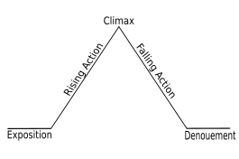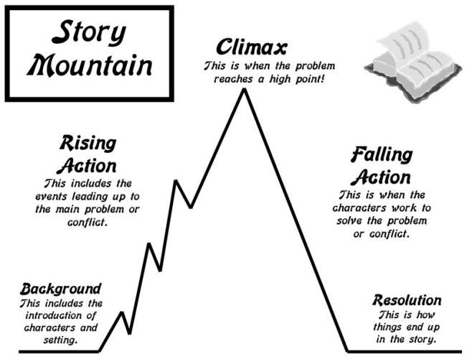

------------------------------------------------------

Week 8:

Files or Handouts (Word, PPT, PDF):

Video:

Web Link: https://www.theatlantic.com/magazine/archive/1941/02/a-worn-path/376236/

------------------------------------------------------

Week 9:

Files or Handouts (Word, PPT, PDF):

Web Link: https://literaryterms.net/theme/

------------------------------------------------------

Week 10:

Files or Handouts (Word, PPT, PDF):

Info: https://www.masterclass.com/articles/complete-guide-to-point-of-view-in-writing-definitions-and-examples

Web Link: https://www.katechopin.org/pdfs/desirees-baby.pdf

------------------------------------------------------

Week 11:

https://www.skyword.com/contentstandard/4-ways-humor-builds-an-emotional-connection-with-audiences/

------------------------------------------------------

Week 12:

Web Link: article: https://researchportal.helsinki.fi/en/projects/literature-and-emotions-creating-emotion-effects-and-affecting-re

https://www.sfu.ca/~egan/FantasyReality.html

------------------------------------------------------

Week 13:

Web Link: https://www.grin.com/document/99449#:~:text=Language%20in%20drama%20is%20represented%20as%20spoken%20language%20or%2C%20in,continuum%20of%20space%20and%20time.

------------------------------------------------------

Week 14:

Web Link: https://www2.hf.uio.no/polyglotta/public/media/libraries/file/10/A%20Dolls%20House-%20Henrik%20Ibsen.pdf

------------------------------------------------------

Week 15: