
Philadelphia University Faculty of Information Technology
Lecturer: Dr. Rawan Abu Lail Department of CS
Internal Examiner: Dr. Raad Alwan Marking scheme
Course Name: Operating System Final Exam Semester one of the academic year:
(750333)
Section:2 2013-2014
Date: 16 /1/ 2013 Time: Two Hours
Familiar Part:
Objective: This part aims to show the student capabilities to distribute semaphores around processes to avoid the problem of concurrent synchronous processes.
Q1(8 marks ) Answer the following MCQ:
1. Which scheduler is responsible for controlling the degree of multiprogramming?
(A) Admission scheduler (B) medium scheduler (C) CPU scheduler (D) None of the above

2. Which is not able to solve the race condition?
(A) Test and Set Lock (B) Shared memory (C) Semaphore (D) Monitor

3. CPU burst distribution is generally characterized as
(A) Constant (B) Linear (C) Polynomial (D) Exponential or hyper-exponential

4. CPU Scheduling algorithms are used for:
(A) Picking one of the ready processes in main memory to run next
(B) Putting to sleep and waking up processes in an efficient manner
(C) Allocating memory to the processes in a fair and efficient way
(D) None of the above

5. Which is not a CPU scheduling criterion?
(A) CPU utilization (B) Throughput (C) Waiting time (D) Burst time

6. Which is a preemptive scheduling?
(A) SJF (B) FCFS (C) RR (D) None of the above

7. Which is not the necessary condition of a deadlock?
(A) Mutual exclusion (B) Hold and wait (C) Preemption (D) None of the above

8. Which of the memory allocation schemes is subject to internal fragmentation?
(A) Multiple Contiguous Fixed Partitions (B) Segmentation (C) Multiple Contiguous Variable Partitions (D) None of the above

Q2(7 marks ) Synchronization
Semaphores are used with their operations to make control on two producers and one consumer run concurrently on shared buffer, where consumer1 is consumed immediately each element that was generated by producer1 or producer2. The producer1 always produces element's value less than 4, while produces two produces the other values. Using semaphores in the following code to satisfy the above requirement. (Hint: elements' values are generated sequentially in ascending order).
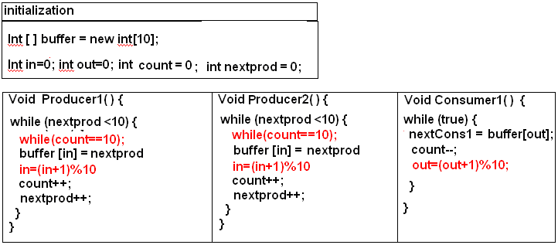
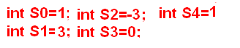
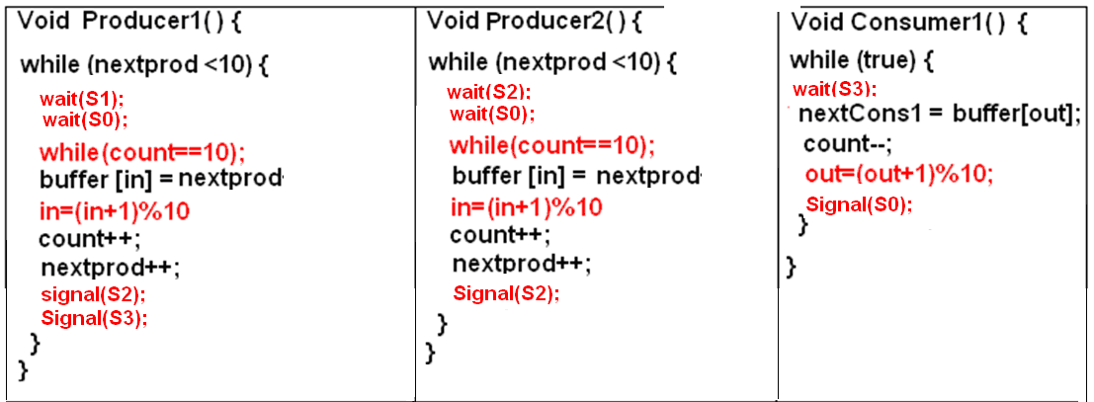

Q3/(7 marks ) Mutual Exclusion and Dead Lock
Let P0, P1, P2 and P3 be four concurrent processes from one program and V0,V1,V2, and V3 are four non-shareable recourses shown below:
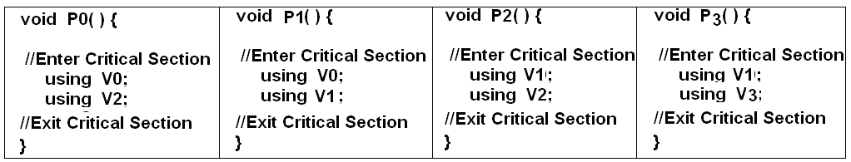

Answer the following:
- A synchronization protocol to solve the problem the critical-section (race condition problem) should be used to satisfy three conditions. What are there?
Ans: 1- Mutual exclusive 2- Progress 3- Bounded wait.

- Draw RAG of the above critical sections?

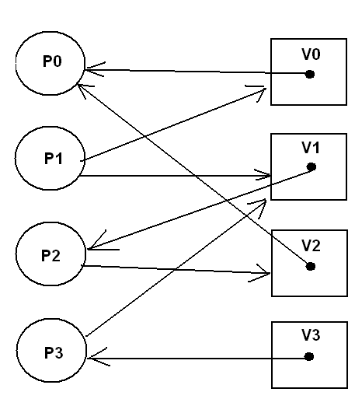

- How processes can use semaphores to enforce safe state.
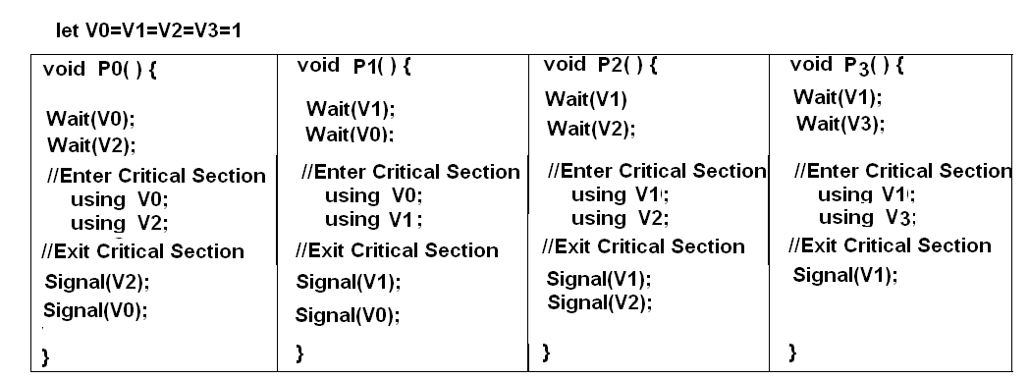

- Using well allocation through Tset and Set function to appear Starvation.
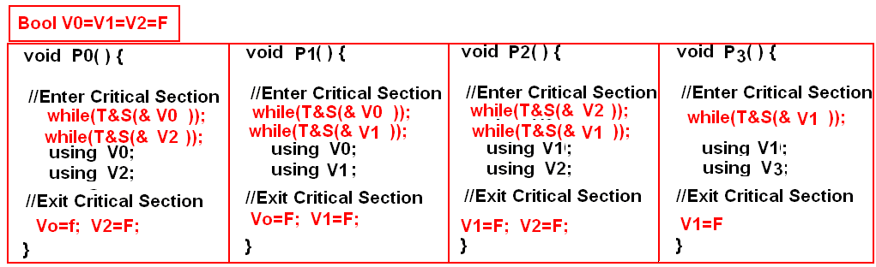

FAMILIAR PART:
Objective: This part aims to show students' capabilities to implement many scheduler policies at the same time on a single CPU.

Q4/(8 marks ) CPU Scheduling

Using “Multilevel Queue with fixed priority for all processes” scheduling algorithm, draw the CPU scheduling Gantt chart and complete the table for the give processes information.
Turn- around time | Response time | Waiting time | The algorithm used | Burst time | Arrival time | Process number | Queue level
85 | 0 | 35 | RR with QT=20 | 50 | 0 | 1 | High
25 | 40 | 10 | RR with QT=20 | 15 | 30 | 2 | High
75 | 55 | 30 | RR with QT=20 | 45 | 35 | 3 | High
157 | 120 | 117 | SJF with QT=10 | 40 | 3 | 4 | Medium
89 | 110 | 79 | SJF with QT=10 | 10 | 31 | 5 | Medium
180 | 160 | 150 | FCFS | 30 | 10 | 6 | Low
195 | 190 | 175 | FCFS | 20 | 15 | 7 | Low

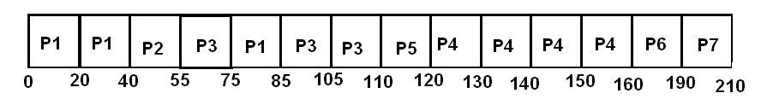

Unfamiliar Part:
Q5 ( 10 marks ) P is a set of processes. R is a set of resources. E is a set of request or assignment edges. The sets P, R, and E are as follows:
P = {P1, P2, P3} R = {R1, R2, R3}
E = {P1 → R2, P2 → R1, P2 → R2, R3→ P2,R1 → P1,R2 → P3, P3→ R3}
R1 has one instance. R2 has two instances. R3 has one instance.
(a) Draw the resource-allocation graph.

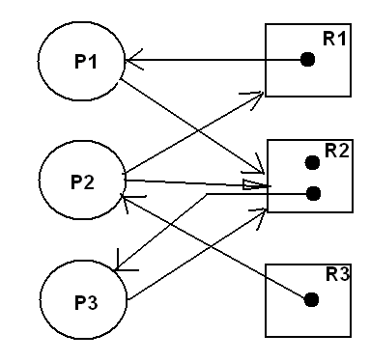

(b) Is there any deadlock in this situation? Briefly Explain through Banker algorithm –safe state part.

$$\text{Allocate}=\begin{aligned}\left(1 0 0 | \right)\left(0 0 1 | \right) \\ \end{aligned}$$
Work=Av=(0 1 0); Finish=(F,F,F)
For i=1
if work >= Need 1
(0 1 0)>=(0 1 0 ) →T
Work=(1 1 0)
Finish=(T,F,F)
For i=2
if work >= Need 2
(1 1 0)>=(1 1 0 ) →T
Work=(1 1 1)
Finish=(T,T,F)

For i=3
if work >= Need 2
(1 1 1)>=(0 1 0 ) →T
Work=(1 2 1)
Finish=(T,T,T)

No deadlock

(c) If deadlock is existed, how to solve the problem.
Ans: Kill one process in deadlock then recheck the safety state OR reallocate resources again.

