
Philadelphia University Faculty of Information Technology
Lecturer: Dr. Rawan Abu Lail Department of CS
Internal Examiner: Dr. Saed Goul Marking Scheme
Course Name: Operating System Second Exam first Semester
(750333)
2014-2015
Date: 10/5/2015 Time: 50 Minutes
Familiar Part:
Objective: This part aim to show the student capabilities to construct synchronization protocol around processes to avoid the problem of processes run concurrently.

Q1(7 marks ) Synchronization
Let us define the following description:
We have four concurrent processes. You don't know in what order they will run, nor do you know when the dispatcher will switch between processes. However, the dispatcher will eventually and continually switch back and forward between processes (i.e., no process will starve).
The initialization code (setting the initial values for the shared variable) is completed before any of the four processes run.
The variable (X) is shared between three processes.

Initialization
int X = 1; int Y=1
Process A  for (; X < 4; X++) {  cout << X;  } | Process B  while (X < 4) {  cout << "a";  } | Process C  while (Y< 3) {  cout << Y;  Y++;  } | Process D  while (X< 4) {  cout << "c";  }

1) ca11ca22ca3

Initialization
int X = 1; int Y=1; bool b1=b2=b3=True; bool b4=false;
Process A  for (; X < 4; X++) { While(T&S(&b1));  cout << X;  b3=False;  } | Process B  while (X < 4) {  While(T&S(&b2));  cout << "a";  b1=False;  } | Process C  while (Y< 3) {  While(T&S(&b3));  cout << Y;  Y++;  b4=False;  } | Process D  while (X< 4) {  While(T&S(&b4));  cout << "c";  b2=False;  }

- 1ac12ac23ac
Initialization
int X = 1; int Y=1; bool b4=b2=b3=True; bool b1=false;
Process A  for (; X < 4; X++) {  While(T&S(&b1));  cout << X;  b2=False;  } | Process B  while (X < 4) {  While(T&S(&b2));  cout << "a";  b3=False;  } | Process C  while (Y< 3) {  While(T&S(&b4));  cout << Y;  Y++;  b1=False;  } | Process D  while (X< 4) {  While(T&S(&b3));  cout << "c";  b4=False;  }

Familiar Part:
Objective: This part aim to show the student capabilities to distribute semaphores around processes to avoid the problem of dead lock and race condition.
Q2(7 marks) Dead lock
Consider four crossroads (intersections) as shown in the following figure.
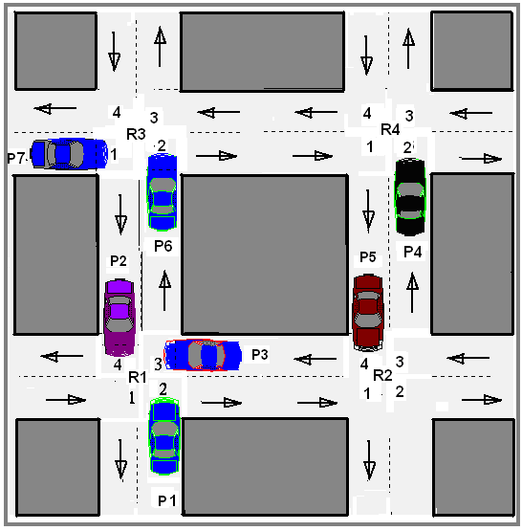 | 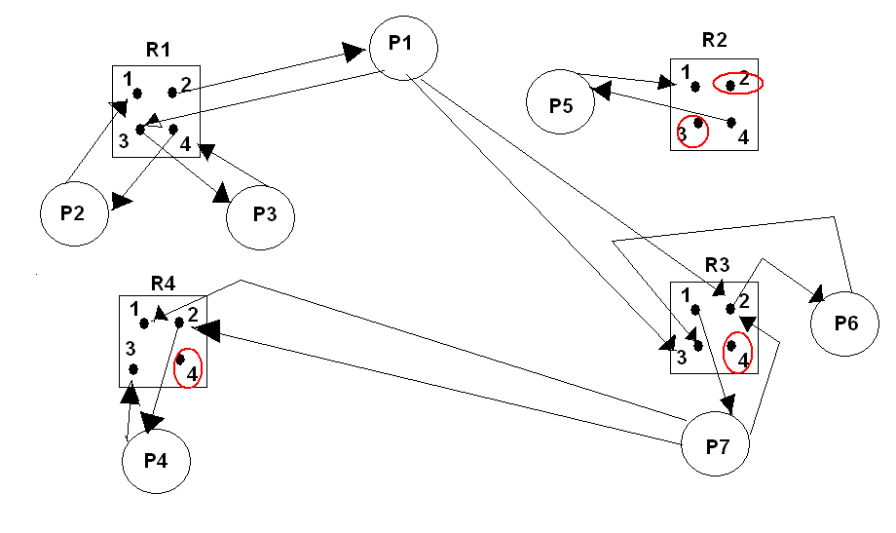

Assume that crossroads represent resources while cars represent processes.
Assume that each car moves straightforward from a crossroad to next one (without turning to the left or right).
Find Allocate and Need matrices with Available and Finish vectors and then apply Banker algorithm to show if the dead lock is existed at the above traffic.

$$\text{Allocate}=\begin{aligned}\left(1 0 0 0 | \right)\left(1 0 0 0 | \right)\left(1 0 0 0 | \right)\left(0 0 0 1 | \right)\left(0 1 0 0 | \right)\left(0 0 1 0 | \right) \\ \end{aligned}$$

Let work=Av=(1 1 1 2)

For i=1
if work >= Need 1
(1 1 1 2)>=(1 0 2 0) →F

For i=2
(1 1 1 2)>=(1 0 0 0) → T
Work=(1 1 1 2)+(1 0 0 0)=(2 1 1 2)
Finish=(F T F F F F F )

For i=1
if work >= Need 1
(2 1 1 2)>=(1 0 2 0) →F

For i=3
(2 1 1 2)>=(1 0 0 0) → T
Work=(2 1 1 2)+(1 0 0 0)=(3 1 1 2)
Finish=(F T T F F F F )

For i=1
if work >= Need 1
(3 1 1 2)>=(1 0 2 0) →F

For i=4
(3 1 1 2)>=(0 0 0 1) → T
Work=(3 1 1 2)+(0 0 0 1)=(3 1 1 3)
Finish=(F T T T F F F )

For i=1
if work >= Need 1
(3 1 1 3)>=(1 0 2 0) →F

For i=5
(3 1 1 3)>=(0 1 0 0) → T
Work=(3 1 1 3)+(0 1 0 0)=(3 2 1 3)
Finish=(F T T T T F F )

For i=1
if work >= Need 1
(3 2 1 3)>=(1 0 2 0) →F

For i=6
(3 2 1 3)>=(0 0 1 0) → T
Work=(3 2 1 3)+(0 0 1 0)=(3 2 2 3)
Finish=(F T T T T T F )

For i=1
if work >= Need 1
(3 2 2 3)>=(1 0 2 0) →T
Work=(3 2 2 3)+(1 0 0 0)=(4 2 2 3)
Finish=(T T T T T T F )

For i=7
if work >= Need 1
(4 2 2 3)>=(0 0 1 2) →T
Work=(4 2 2 3)+(0 0 1 0)=(4 2 3 3)
Finish=(T T T T T T T )

No dead lock

Q3/( 6 marks) :

Let P0, P1, and P2 be concurrent processes from one program.
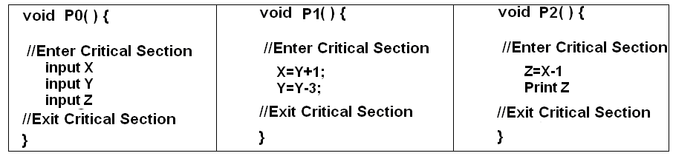
The correct answer is reached if CPU scheduling executes P0, then P1, then P2 with no preemption.

Answer the following:
- Show how the processes can implement semaphores to enforce mutual exclusion during critical sections of code and thereby safely coordinate access to X, Y, and Z along with other works they do.

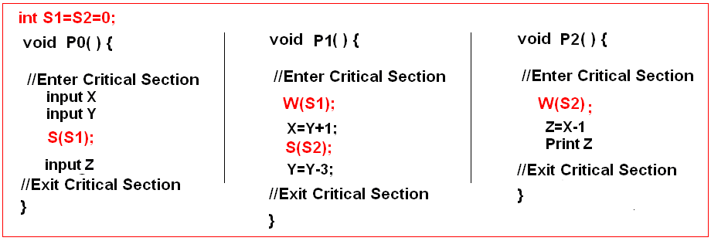

- Using semaphores with incorrect semaphores distribution to show how it is possible for the processes to deadlock if they can enter critical regions of both of their shared variables at the same time.
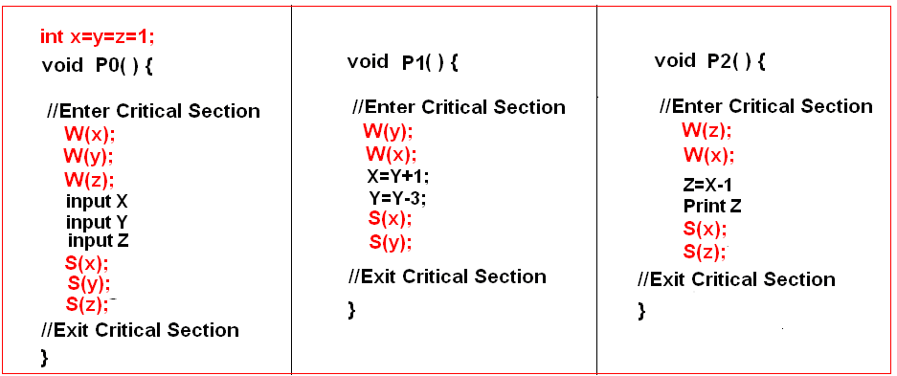

- Show how progress is not satisfied by using three system variables in the synchronization protocol of critical sections.

