Philadelphia University |  |  | Faculty of information Technology
Coordinator: Mrs. Eman Alnaji |  |  | Department of Computer Science
Internal Examiner: Dr. Maram Bani Younis |  |  | Examination Paper
Computer Skills (9761111)  Computer Skills – Humanities (0710103) | First Exam |  | First Semester of Academic Year 2015/2016
Date: 14 November 2015 |  |  | Time: 50 minutes A
Student No.: ...................................... Student Name: .............................................................
Lecturer: .......................................... Section No.: ..................................................................

Information for candidates
- This examination paper contains 20 questions, totaling 20 marks
- Marks of Each Question is 1.

Advice to Candidates
1. You should attempt all questions.
2. You should write your Answers clearly in the specified place in the first page.

Question | Answer
1
2
3
4
5
6
7
8
9
10
11
12
13
14
15
16
17
18
19
20

Q1: In Excel 2010, the name of the part displayed in the following image is:
- Cell
- Ribbon
- Tab
- Quick Access Toolbar

Q2: In the image below; the cell reference of the selected cells is:

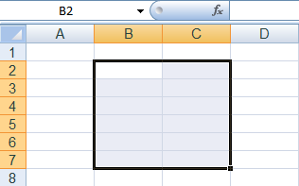

- B2:B7
- 7B:7C
- B2:C7
- B7:C7

Q3: In the image below, the active sheet is:

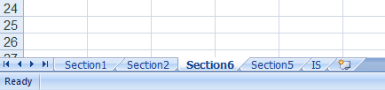

- Section1
- Section2
- Section6
- IS

Q4: You can use the options displayed below for:

- Changing a cell style
- Removing a cell style
- A + B
- Applying Conditional Formatting

Q5: To display your table as shown in the image below, you should use:

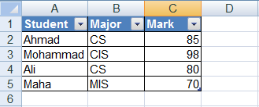

- Conditional Formatting
- Format as Table
- Cell Styles
- Format Cells

Q6: The following dialog box is used for:
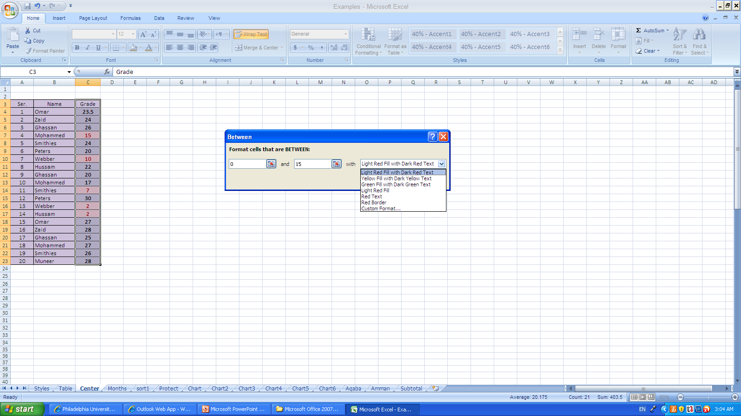
- Sorting
- Filtering
- Conditional formatting
- All of the above

Q7: In the image below, we can refer to the selected range with:

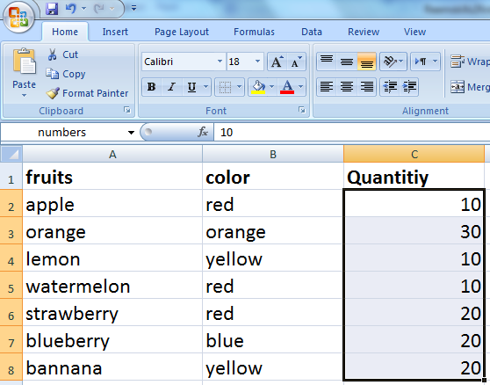

- C2:C8
- numbers
- quantity
- A + B

Q8: In the image below; the operation in the displayed paste special dialogue box that is used to paste row data in a column or column data in a row is:

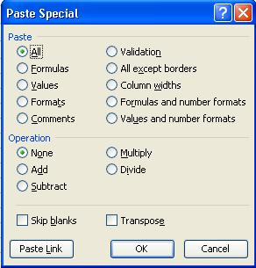

- Formulas
- Skip blanks
- Column widths
- Transpose

Q9: In the image below, if we click on Sort oldest to newest, the first cell well be:
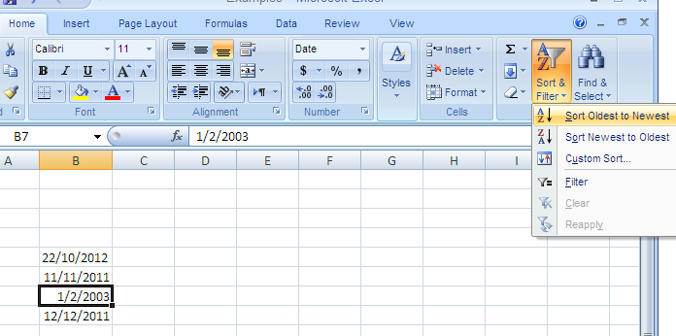
- 22/10/2012
- 11/11/2011
- 1/2/2003
- 12/12/2011

Q10: After applying the sorting displayed in the following image, the last row in the table will be:

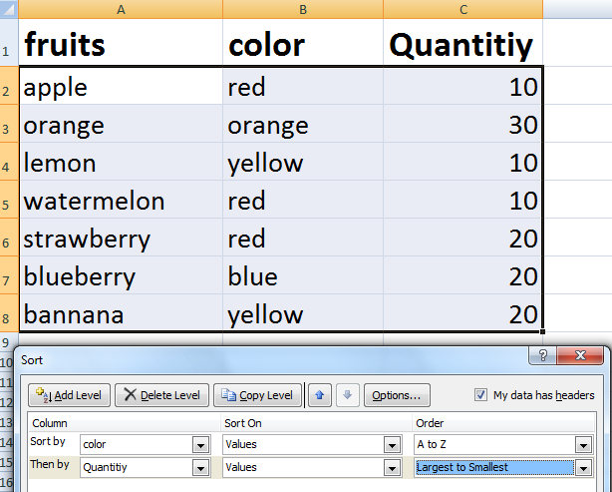

- lemon, yellow, 10
- blueberry, blue, 20
- banana, yellow, 20
- orange, orange, 30

Q11: If you press OK in the dialog below, then:

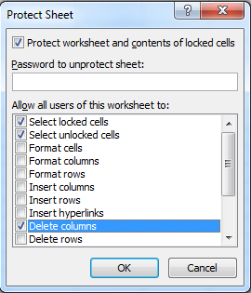

- You can delete columns from the sheet but you cannot insert columns
- You can insert columns in the sheet but you cannot delete columns
- You can insert columns and rows to the sheet
- You cannot delete neither columns nor rows from the sheet

Q12: In the image below, selecting the option "Structure" from the dialog will:

- Prevent users from moving windows
- Prevent users from deleting, copying, moving or inserting worksheets
- Prevent users from resizing windows
- Prevent users from closing windows

Q13: In the image below, selecting the option "Hidden" and then protecting the sheet means:

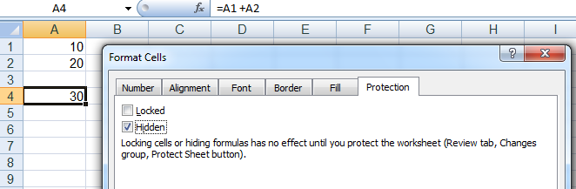

- The formula will be displayed in the cell
- The formula will be deleted from the cell, and not be applied
- The formula will still be applied in the cell, but not displayed in the formula bar.
- Cell A4 will become empty

Q14: In the image below; the small triangle in the top right corner of cell A2 (usually colored by red) means:

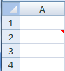

- There is an error in the cell
- The cell can be used only to insert a formula
- The font color of the cell is red
- There is a comment inserted into the cell

Q15: Which of the following functions will return number 9?
- TODAY()
- MONTH("5-Sep-99")
- DAY("9-Nov-99")
- B + C

Q16: To display the current date and time in a cell, you use the function:
- TODAY()
- NOW()
- DAY()
- MONTH()

Q17: The result of the formula =LEFT(RIGHT("this is skills exam";19);19) :
- this is skills exam
- THIS IS SKILLS EXAM
- this is skill
- this is

Q18: In the image below, after applying the formula in A3, the resulted value will be:

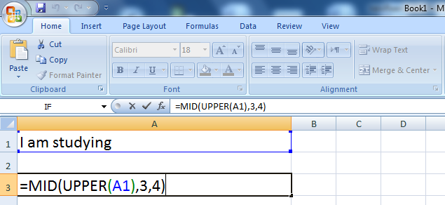

- AM S
- I AM
- Am s
- AM ST

Q19: What is the output of the following formula =LOWER("this is A final test") ?
    - THIS IS A FINAL TEST
    - This Is A Final Test
    - This is a final test
    - this is a final test

Q20: The result of the formula =UPPER(PROPER("IT faculty is the best")), is:
- it faculty is the best
- It Faculty Is The Best
- IT FACULTY IS THE BEST
- iT fACULTY iS tHE bEST

Good Luck
☺

