Philadelphia University |  |  | Faculty of information Technology
Coordinator: Mrs. Eman Alnaji |  |  | Department of Computer Science
Internal Examiner: Dr. Maram Bani Younis |  |  | Examination Paper
Computer Skills (9761111)  Computer Skills – Humanities (0710103) | Second Exam |  | First Semester of Academic Year 2015/2016
Date: 27 December 2015 |  |  | Time: 50 minutes A
Student No.: ...................................... Student Name: .............................................................
Lecturer: .......................................... Section No.: ..................................................................

Information for candidates
- This examination paper contains 20 questions, totaling 20 marks
- Marks of Each Question is 1.

Advice to Candidates
1. You should attempt all questions.
2. You should write your Answers clearly in the specified place in the first page.

Question | Answer
1
2
3
4
5
6
7
8
9
10
11
12
13
14
15
16
17
18
19
20

Q1: The extension of an Access 2010 file, is:
- accdb
- mdb
- acdb
- db

Q2: Changes applied on Table fields in the design view:
- Are saved automatically by Ms Access 2010
- Should be saved by the user.
- Cannot be changed later on
- All of the above.

Q3. In the picture below, number of tables in the created database is:

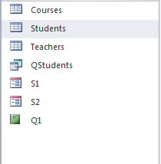

- 1
- 2
- 3
- Unknown

Q4: According to the following field properties, if the user enters the product "milk" in the
“pro-name” field, which of the following results will be seen?
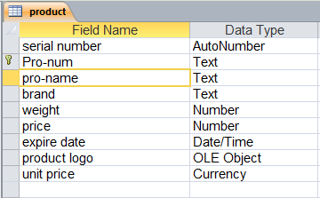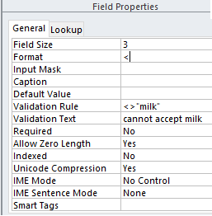

  - MIL
  - Milk
  - mil
  - Message says: cannot accept milk

Q5: For the following table; to prevent the user from inserting numbers less than 1 or greater than 20 in the “price field” (1 and 20 are not allowed), the correct property(s) that must be set is:
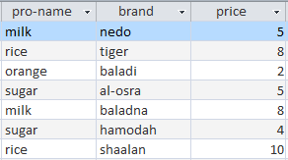

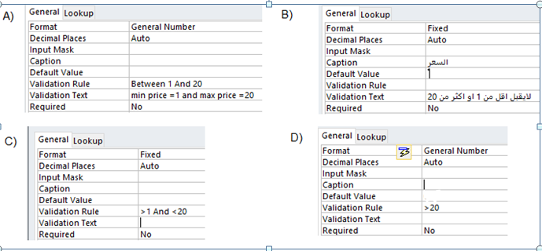

Q6: In the picture below, the data type of the field “repeated” is:
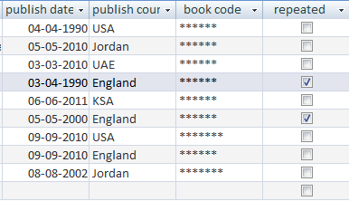

- Memo
- Attachments.
- Yes/No
- Text.

Q7: In the picture below (the design view of table "Students"), when "Delete Rows" is clicked, you will:

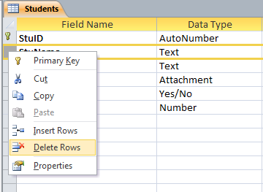

- Delete a record
- Delete a field
- Delete a table
- Delete a text

Q8: In the picture below, the primary key of "Books" table is:

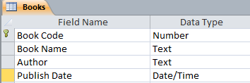

- Book Code
- Book Name
- Author
- No primary key is selected

Q9: Which of the following is correct about the relashionship displayed below, between tables "Students" and "University":

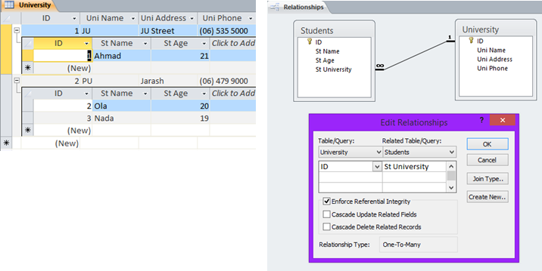

- You can change the value in field "University.ID" to 3 in the first record (Uni Name = "JU")

- The first record in "University" table can be deleted directly with neither an error nor warning message.

- When trying to delete the first record in "University" table, a message is displayed to ask the user whither he/she is sure to delete the record along with its related records in table "Students". If, yes, all these records will be deleted.

- When trying to update the first record in "University" table, an error message will be displayed to notify the user that the record cannot be deleted because it has related records in "Students" table.

Q10: In the picture below, after executing the following query on table "books", the first record will be:

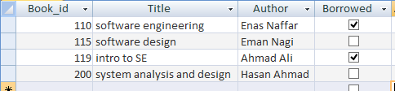

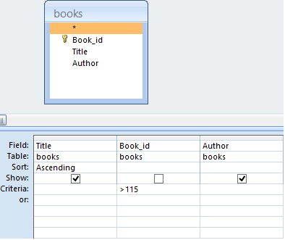

- intro to SE, 119, Ahmad Ali
- system analysis and design, 200, Hasan Ahmad
- system analysis and design, Hasan Ahmad
- intro to SE, Ahmad Ali

Q11: In the picture below, after executing the following query on table "books", the result will be:

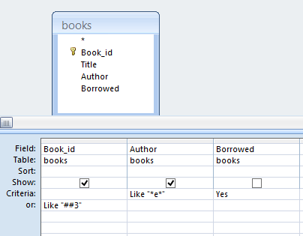

- 110, Enas Naffar, Yes
- 110, Enas Naffar
- 110, Enas Naffar
115, Eman Nagi
- No records will be displayed

Q12: In the picture below, after executing the following query on table "teams", the result will be:

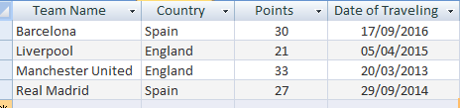
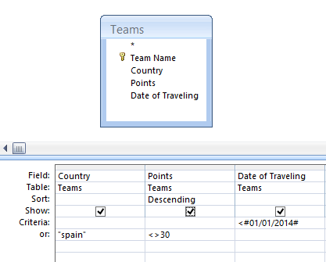

- 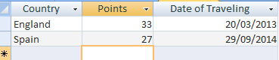

- 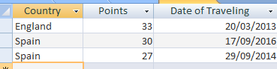

- 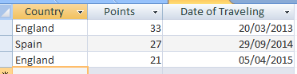

- None of the above

Q13: If you need to create query to show all student records who their names having the third letter = “s”, the criteria will be:

- Like "**s"
- Like "s**"
- Like "??s*"
- Like "##s*"

Q14: In the picture below, if the criteria Like “*[ae]*” is used, how many records will be displayed as a result for this query?

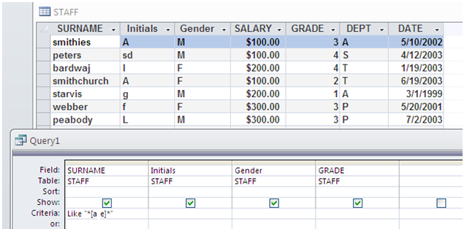

- 0
- 1
- 6
- 7

Q15: In the picture below, the result of the displayed query is:

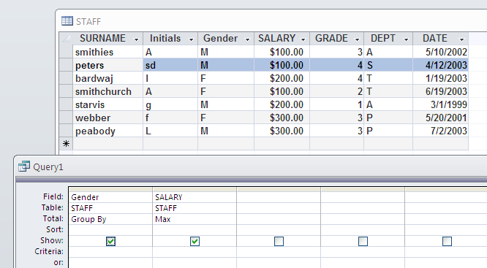

A)
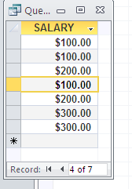

B)
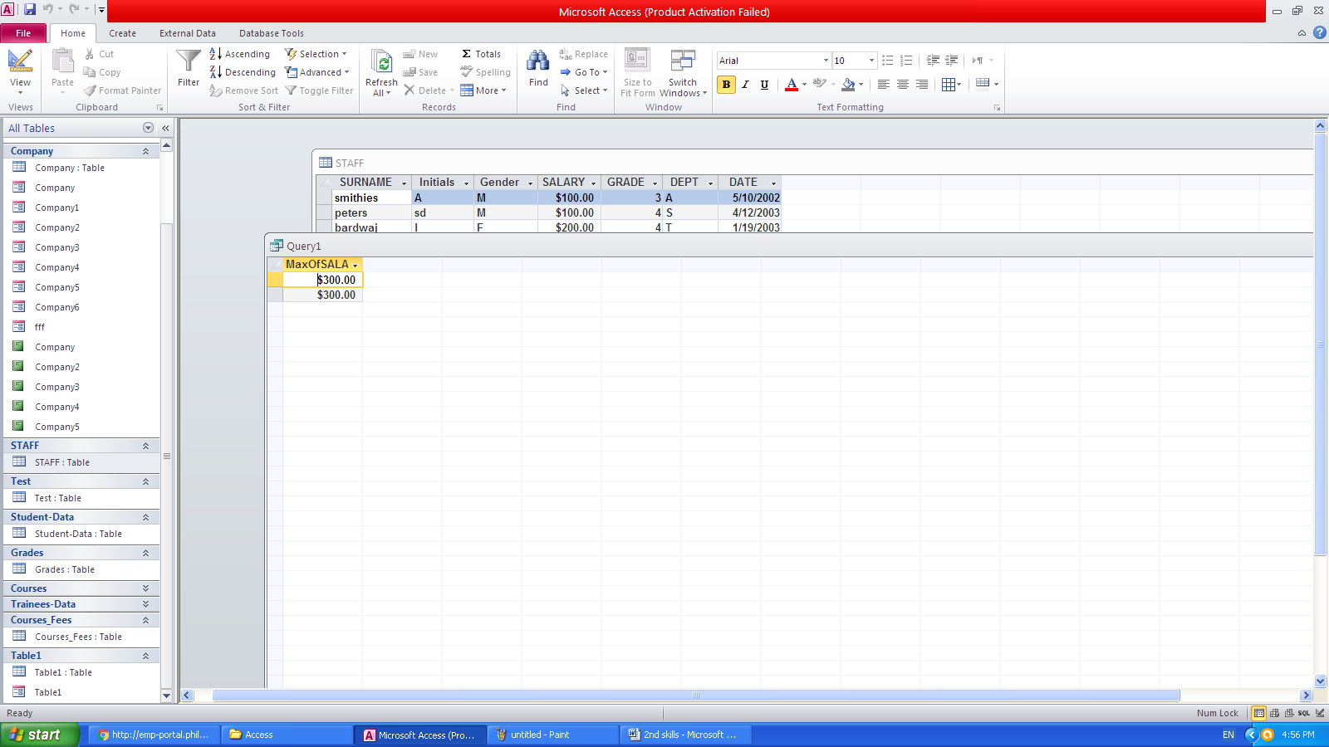

C)
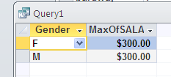

D)
Q16: In the picture below, after pressing the “OK” button below, the result will be:

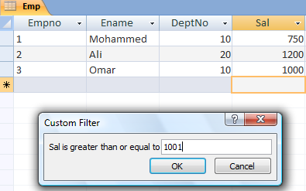

- 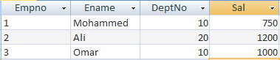

- 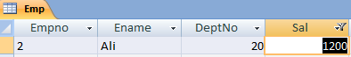

- 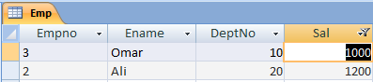

- 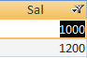

Q17: In the picture below, the number of records to be displayed after applying the following query, on tables "Dept" and "Emp", is:

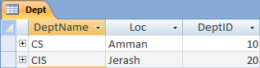

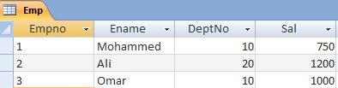

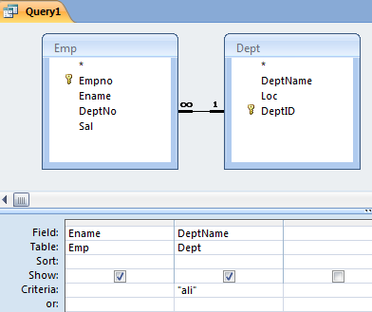
- 1
- 0
- 3
- None of the above

Q18: In the picture below, to create and move to new record in the displayed form, you should click on:

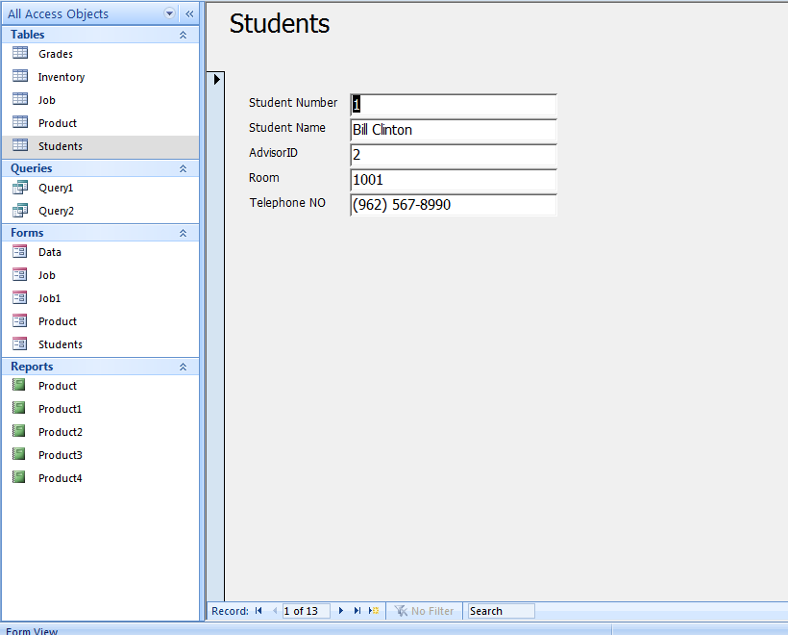

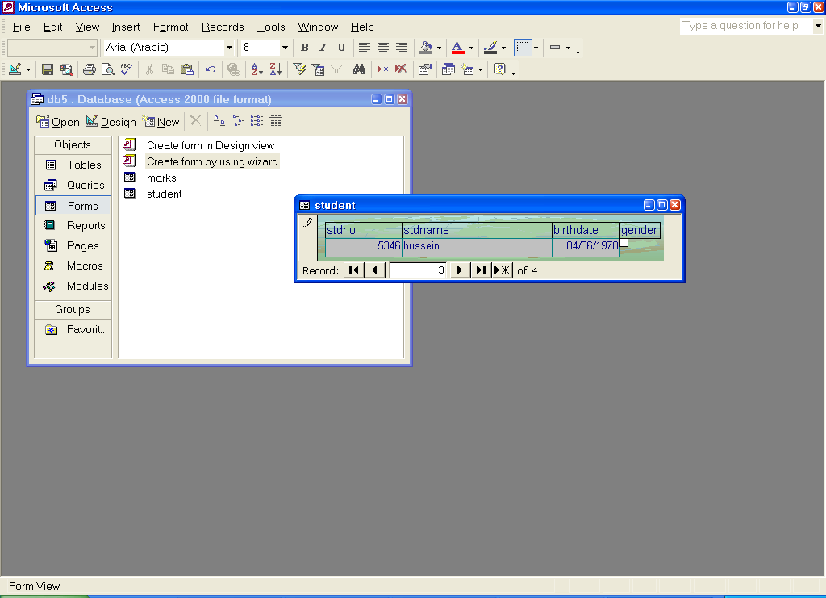

Q19: In the picture below, the Design layout of the displayed form is called

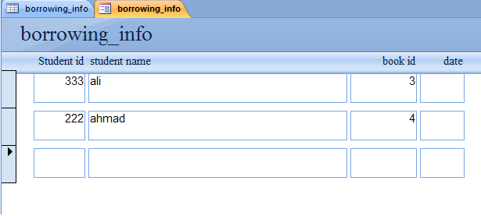
  - Columnar.
  - Tabular.
  - Datasheet.
  - Justified.

Q20: In the picture below, the records displayed in Product report, has been grouped by field:

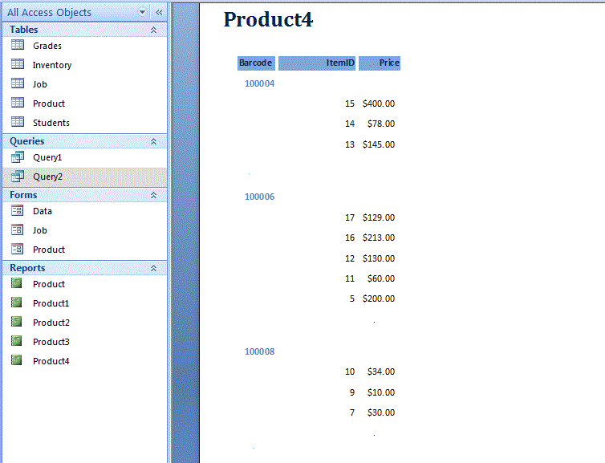

- Barcode
- ItemID
- Price
- B + C

Good Luck
☺

