
جامعة فيلادلفيا
كلية تكنولوجيا المعلومات
قسم علم الحاسوب

Programming Fundamentals
(750113)
Practical works


Miss: Hanan Hardan

Lab Work 1

Objectives: This lab work aims to understanding C++ Environment

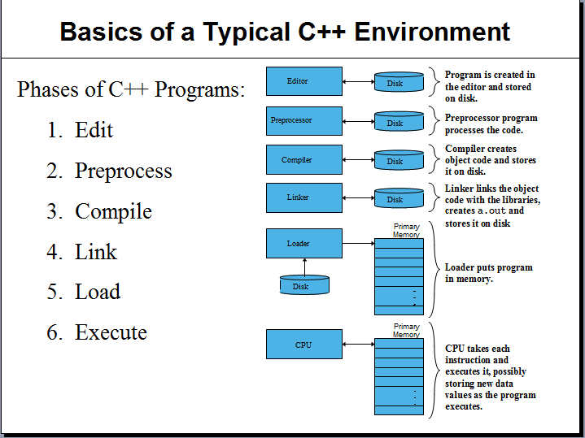

- Microsoft Visual C++ 6.0 is a powerful, sophisticated software package. It can be used by a novice or by a professional designing sophisticated Windows application. In this introductory course, we will only be using a small portion of the capabilities of this software package.
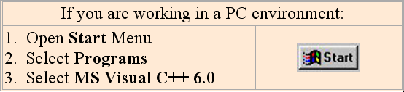
Let's get started!

- When the Tip of the Day dialog box appears, close it by clicking on the Close button. If you do not want to see the Tip of the Day every time you open Visual C++, click the Show tips at Startup check box to remove the check mark and deselect this feature.
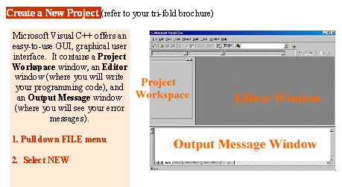

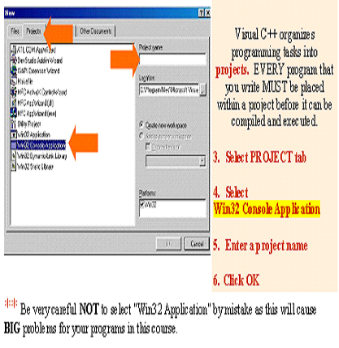

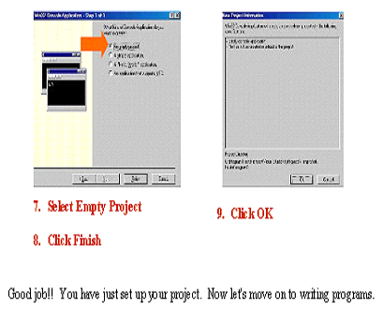
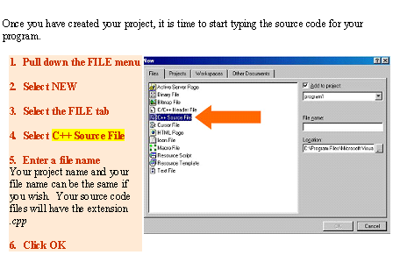
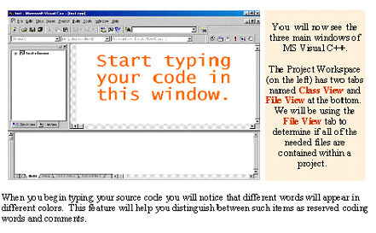
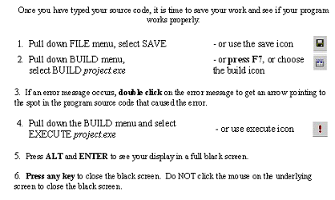

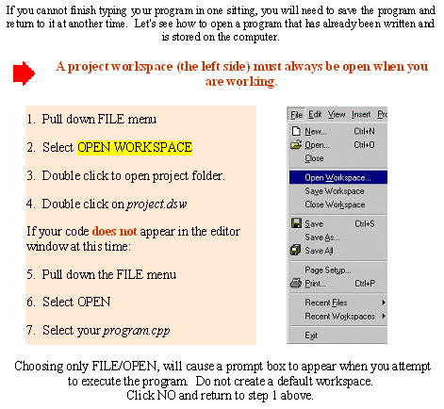
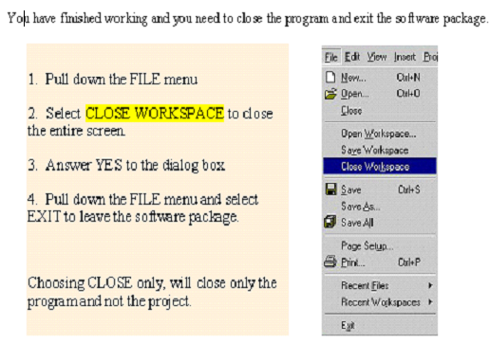
The Following is a sample C++ Program:

#include<iostream.h>
void main()
{
cout<<"Welcome to C++ programming.”;
}

Lab Work 2

Objectives: This lab work aims to test your understanding of "Comments and output statements"

Comments:
//This is a C++ program.
//Welcome to C++ programming.

/*
You can include comments that can
occupy several lines.
*/

Output Statements:
- Commonly used Escape sequences
 | Escape sequences | Description
\n | Newline | Cursor moves to the beginning of the next line
\t | Tab | Cursor moves to the next tab stop
\b | Backspace | Cursor moves one space to the left
\r | Return | Cursor moves to the beginning of the current line
\\ | Backslash | Backslash is printed
\’ | Single quotation | Single quotation mark is printed
\” | Double quotation | Double quotation mark is printed

- New line by using (endl)
cout<<endl ;
- Print any Text or messages:
cout<<”\n Welcome”;
cout<<” to C++”;
cout<<”***********”;
cout<<”\n Welcome \n to \n\n C++! \n”;
cout<<”\t Welcom \t to \t C++ \n” ;

cout<<"Ahmad"<<endl;
cout<<""657";
cout<<endl;
cout<<"lab509\n";
cout<<"2+5";
cout<<endl<<"Enter your name";
cout<<"\nEnter integer number";

Q1: Write a program that output the following:

9

18

128

****************
A B C

D

E F G

Home Work:

Q2: Write a program that produces the following output:

*****************************************
* Programming Assignment 1 *
* Computer Programming 1 *
* Author: ??? *
* Due Date: Thursday, Jan. 24 *
*****************************************

Q3: Write a program that produces the following output:

CCCCCCCCC ++ ++
CC ++ ++
CC ++++++++++ ++++++++++
CC ++++++++++ ++++++++++
CC ++ ++
CCCCCCCCC ++ ++

Lab Work 3.1

Objectives: This lab work aims to test your understanding of "output statements"
Output Statements:
1. Print any thing direct
- Number:
cout<<3;
- Character:
cout<<'A';
cout<<'8';
cout<<'?';

- Print the result of expression direct
- Arithmetic:

cout<<”2+6/8*2=”<<2+6/8*2<<endl;

- Relational:

cout<<”2>7=”<<2>7<<endl;
cout<<” (5+6>=10)=”<<5+6>=10<<endl;

- Logical:
cout<<true<<endl;
cout<<false<<endl;
cout<< true&&false<<endl ;

- mixed expression:
#include <iostream.h>
void main() {
int a=10, b=3;
cout<<"\n a+b= \t"<<a+b;
cout<<"\n a+b*2= \t"<<a+b*2;
cout<<"\n (a+b)*2 \t"<<(a+b)*2<<endl;
cout<<a<<'<'<<b<<" is\t"<<(a<b);
cout<<"\n a+b != a+3 is \t"<<(a+b != a+3);
cout<<"\n a+b >= b*2 || a>b+9 is \t"<<(a+b >= b*2 || a>b+9)<<endl;}
Lab Work 3.2

Objectives:This lab work aims to using the following manipulators to format the input and output
Manipulator | Effect
des  hex  oct  setw(n)  setfill(c)  left  right  fixed  setprecision(n)  showpoint | Input or output in decimal  Input or output in hexadecimal  Input or output in octal  Set field width to n  Make c the fill character  Left-justify  Right-justify  Use fixed notation for floating-point number: d.ddd  Set floating-point precision to n  Always print decimal point and trailing zeros

Example1:
int i=91;
cout<<”i=”<<i<<endl;
cout<<”i=”<<oct<<i<<endl;
cout<<”i=”<<hex<<i<<endl;
cout<<”i=”<<des<<i<<endl;
cout<<”i=”<<i<<endl;

Example2:
int i=1;
cout<<setw(6)<<i<<endl;
i=i*10;
cout<<setw(6)<<i<<endl;
i=i*10;
cout<<setw(6)<<i<<endl;
i=i*10;
cout<<setw(6)<<i<<endl;
Example 3:
int i=1;
cout<<setw(6)<<i<<endl;
i=i*10;
cout<<i<<endl;
i=i*10;
cout<<i<<endl;
i=i*10;
cout<<i<<endl;
Example 4:
int i=1;
cout<<setfill(‘*’);
cout<<setw(6)<<i<<endl;
i=i*10;
cout<<setw(6)<<i<<endl;
i=i*10;
cout<<setw(6)<<i<<endl;
i=i*10;
cout<<setw(6)<<i<<endl;
Example 5:
int a=5, b=43, c=104;
cout<<left<<setw(10)<<”Karen”<<right<<setw(6)<<a<<endl;
cout<<left<<setw(10)<<”Ben”<<right<<setw(6)<<b<<endl;
cout<<left<<setw(10)<<”patricia”<<right<<setw(6)<<c<<endl;
Example 6:
float a=5, b=43.3, c=10304.31;
cout<<showpoint<<fixed<<setprecision(2);
cout<<setw(8)<<a<<endl;
cout<<setw(8)<<b<<endl;
cout<<setw(8)<<c<<endl;

Example 7: (if the showpoint and fixed are not used)
float a=5, b=43.3, c=10304.31;
cout<<setprecision(2);
cout<<setw(8)<<a<<endl;
cout<<setw(8)<<b<<endl;
cout<<setw(8)<<c<<endl;

Lab Work 4

Objectives: This lab work aims to test your understanding of “Data definition, initializing variable, input statement and output statements”
Data definition(declaring and initializing variable):

Q1: Consider the following program segment
//include statement
void main()
{
//variable declaration
//executable statements

}
- Write C++ statements that include the header files iostream.h
- Write C++ statements that declare the following variables:
x of type integer
y of type float
z of type double
a of type character
b,c of type Boolean
- Write C++ statements that store
5 into x
2.5 into y
195.555 into z
‘s’ into a
true into b
false into c
(in the declaration statements or in other statements).
- Write C++ statements that print the value of the above variables into output screen.
- Write C++ statements that print the summation of x and y values into output screen.
- Write C++ statements that print the summation of x and z values into output screen.
- Write C++ statements that print the summation of y and z values into output screen.
- Write C++ statements that print the value of (b && c) into output screen.
- Write C++ statements that print the value of (b || c) into output screen.
- Write C++ statements that print the value of (! b) into output screen.
- Write C++ statements that print the value of (! c) into output screen.

Input statements:
Q2: Consider the following program segment
//include statement
void main()
{
//variable declaration
//executable statements

}
- Write C++ statements that include the header files iostream.h
- Write C++ statements that declare x variable of type integer.
- Write C++ statements that prompt the user to input integer number and store the number in x.
- Write C++ statements that output the value of x.
- Compile and run your program

Q3: Consider the following program segment
//include statement
void main()
{
//variable declaration
//executable statements

}
- Write C++ statements that include the header files iostream.h
- Write C++ statements that declare the following variables: x, y and z of type float.
- Write C++ statements that declare the following variables: a, b and c of type character.
- Write C++ statements that prompt the user to input 3 decimal numbers and store them in x, y and z.
- Write C++ statements that prompt the user to input 3 characters and store them in a, b and c.
- Write C++ statements that output the value of x, y and z.
- Write C++ statements that output the value of a, b and c.
- Compile and run your program

Lab Work 5

Objectives: This lab work aims to test your understanding of “Assignment statements”

Assignment statement:

Q1: Consider the following program segment
//include statement
void main()
{
//variable declaration

//executable statements

}
- Write C++ statements that include the header files iostream.h
- Write C++ statements that declare x, y and z variables of type integer.
- Write C++ statements that prompt the user to input integer number and store the number in x.
- Write C++ statements that store the value of x in y.
- Write C++ statements that add 2 to the value of x and store the result in x.
- Write C++ statements that sum the value of (x , y) and store the result in z
- Write C++ statements that output the value of x, y and z.
- Compile and run your program

Q2: Consider the following program segment
//include statement
void main()
{
//variable declaration

//executable statements

}

- Write C++ statement that include the header files iostream.h
- Write C++ statement that declare x, y, z and m variables of type integer.
- Write C++ statement that declares r of type integer and initializing it with 12.
- Write C++ statements that prompt the user to input 2 integer numbers and store the number in x and y.
- Write C++ statements that store the value of ( x – y +5) in z.
- Write C++ statements that store the value of (z-r) in m.
- Write C++ statements that output the value of m.
- Compile and run your program

Home Work:

Q3: Write a program that displays the results of the following expressions:

- A=B % 15
- R=$X^{2}$ + Y/5
- Z= X > ( B+Y )

Q4: Write a C++ program that input three floating variables and calculate
- Their summation
- Their average

Q5: Write a program that converts the temperature from Fahrenheit to Centigrade.
Hint: $C=\frac{F−\text{32}}{1\text{.}8}$

Lab Work 6

Objectives: This lab work aims to test your understanding of "Basic concepts” and practice on programming some problems with different statements in the lab hours during this week.

Q1: Write a program that determines the volume of a swimming pool
Hint: Volume=length*width*depth

Q2: Write a program that prompts the user to input the length and width of a rectangle and then prints the rectangle’s area. (Assume that the length and the width are decimal numbers)

Q3: Write a program that prompts the user to enter 4 test scores and then prints the average test score.

Home Work:

Q4: Write a program that prompts the user to input a four-digit positive integer. The program then outputs the digits of the number, one digit per line for example, if the input is 3245, and the output is:
3
2
4
5

Q5: Write a C++ program that prompts the user to input the elapsed time for an event in seconds. The program then outputs the elapsed time in hours, minutes, and seconds. (For example, if the elapsed time is 9630 second, then the output is 2:40:30

Q6: Find the total salary for salesman has a basic salary 300 JD and commission 15% from his sales, and discount 5.5% from his basic salary as social insurance. Where total salary= total income-total discount

Lab Work 7

Objectives: This lab work aims to test your understanding of "if statement" and practice on programming some problems with if statements in the lab hours during this week.

One way selection statement:

Q1: Write a C++ program that reads a student mark and print the following:
- “Success” if student mark is greater than or equal 50.
- “Fail” otherwise.

Q2: Write a program that inputs an integer – determines if it is even or odd

Q3: Write a program that inputs an integer – determines if it is positive or negative

Lab Work 8

Objectives: This lab work aims to test your understanding of "if statement" and practice on programming some problems with if statements in the lab hours during this week.

Two way selection statement:

Q1: Write a C++ program that reads a student mark and print the following:
- “Success” if student mark is greater than or equal 50.
- “Fail” otherwise.

Q2: Write a program that inputs an integer – determines if it is even or odd

Q3: Write a program that calculate the area for quadrangle shape, where A=H*W then determine if this shape is rectangle or square

Home Work:

Q4: Write a program which takes three sides a, b and c of a triangle as input and calculates its area if these conditions are satisfied a+b>c, b+c>a, and a+c>b

(Help area=$\sqrt{s(s−a)(s−b)(s−c)}$, where s=(a+b+c)/2 )

Q5: Consider the following equations:
R=$\begin{aligned}\left\{x^{2},x>o | \right\}\end{aligned}\left\{\right\}$
Write a program to compute the value of R.

Lab Work 9

Objectives: This lab work aims to test your understanding of "if statement" and practice on programming some problems with if statements in the lab hours during this week.

Multiple selections (Nested If):
Q1: Write a program that inputs a character code and print its equivalent from the table below
Input Code | Marital Status
M | Married
S | Single
D | Divorced
W | Widow

Q2: Write a program that prompts the user to input three numbers. The program should then output the numbers in ascending order.

Q3: Consider the following equations:
Z=$\begin{aligned}\left\{x^{2},x>o | \right\}\left\{x^{3},x<0 | \right\}\end{aligned}\left\{\right\}$

Write a program to compute the value of z.
Home Work:

Q4: Write a program that inputs a student mark and outputs the corresponding rank, where ranks are as follows:

Mark | Rank
90 – 100 | Excellent
80 – 89 | Very good
70 - 79 | Good
50 – 69 | Accepted
0 – 49 | Failed

Q5: Write a program that calculate employee total salary, if you know the basic salary is 400 JD and he get a bonus 15% from his sales if his sales not more 1000JD and 20% if he exceed 1000 to 2000, otherwise 25% from his sales. And discount 20% from income if exceed 700JD otherwise 15%.
Hint: total salary= total income – total discounted .

Lab Work 10

Objectives: This lab work aims to test your understanding of "switch statement" and practice on programming some problems with if statements in the lab hours during this week.

Switch structures:

Q1: Write a program that inputs a character code and print its equivalent from the table below

Input Code | Marital Status
M | Married
S | Single
D | Divorced
W | Widow

Q2: Write a program which takes a character as input and checks whether it is a vowel or consonant.

Q3: Write a program which takes a character as input and check whether it is a vowel, consonant, or special character.

Home Work:

Q4: Write a program to make a simple calculator which should be able to do +,-,*,/,% Operations.

Q5: In the following program convert (if-else) selection statement to (switch) statement.

#include <iostream.h>
void main()
{
cout << "Enter int: ";
int number;
cin >> number;
if (number==1|| number==2|| number==3)
{
cout << "Your number was 1, 2, or 3." << endl;
}
else if (number==4|| number==5|| number==6)
{
cout << "Your number was 4, 5, or 6." << endl;
}
else {
cout << "Your number was above 6." << endl;
}
}

Lab Work 11

Objectives: This lab work aims to test your understanding of "Basic concepts” and practice on programming some problems with different statements in the lab hours during this week

Q1: In a right triangle, the square of the length of one side is equal to the sum of the squares of the lengths of the other two sides, write a program that prompts the user to enter the lengths of three sides of a triangle and then outputs a message indicating whether the triangle is a right triangle.

Q2: The roots of the quadratic equation ${\text{ax}}^{2}+\text{bx}+c=0,a≠0$ are given by the following formula $\frac{−b±\sqrt{b^{2}−4\text{ac}}}{2a}$
In this formula, the term $b^{2}−4\text{ac}$ is called the discriminate. If $b^{2}−4\text{ac}$=0 then the equation has a single (repeated) root. If $b^{2}−4\text{ac}$>0. the equation has two real root. If $b^{2}−4\text{ac}$<0 the equation has two complex root. Write a program that prompts the user to input the value of a (the coefficient of $x^{2}$), b (the coefficient of x), and c (the constant term), and outputs the type of roots of the equation. Furthermore, if $b^{2}−4\text{ac}$>=0 the program should output the roots of the quadratic equation.

Home Work:

Q3: Write a program that determines the average life expectancy of a standard light bulb, where the type of the bulb is given in Watts and its life is measured by hours as follows:
Watts Life
25 2500
40 , 60 1000
100 750

Q4: Write a program that converts the temperature from siliceous to Fahrenheit and vise versa. (You should determine the input type and then make the appropriate conversion.

Lab Work 12

Objectives: This lab work aims to test your understanding of "loop structures" and practice on programming some problems with different loop statements in the lab hours during this week.

Counter Control Loop (Using For Statement):

Q1: Write a program that out put the following:
20 18 16 14 12 10 8 6 4 2 0

Q2: Write a program that prints all the odd numbers between 50 and 100

Q3: Write a program that input two integers N and M and out put $M^{N}$
Hint: The student cannot use the build in function POW.

Lab Work 13

Objectives: This lab work aims to test your understanding of "loop structures" and practice on programming some problems with different loop statements in the lab hours during this week.

Counter Control Loop (Using For Statement):
Home Work:
Q1: Write a program to calculate the following:
Y=$1+\frac{1}{2}+\frac{1}{3}+\frac{1}{4}+\text{.}\text{.}\text{.}\text{.}\text{.}\text{.}\text{.}\text{.}\text{.}\text{.}+\frac{1}{n}$
Q2: Write a program to calculate the following:
- Z=$1+\frac{2}{4}+\frac{3}{9}+\frac{4}{\text{16}}+\frac{5}{\text{25}}+\text{.}\text{.}\text{.}\text{.}\text{.}\text{.}\text{.}\text{.}\text{.}\text{.}+\frac{n}{n^{2}}$
- Z=$1−\frac{2}{4}+\frac{3}{9}−\frac{4}{\text{16}}+\frac{5}{\text{25}}−\text{.}\text{.}\text{.}\text{.}\text{.}\text{.}\text{.}\text{.}\text{.}\text{.}+\frac{n}{n^{2}}$
Home Work:

Q3: Write a program to calculate the following:
A=$\sum_{x=1}^{\text{10}}{X^{2}}$
Q4: Write a program to calculate the following:
B=$\sum_{x=1}^{n}{X^{2}}$
Q5: Write a program to calculate the following:

C=$\sum_{x=m}^{n}{X^{2}}$

Lab Work 14

Objectives: This lab work aims to test your understanding of "loop structures" and practice on programming some problems with different loop statements in the lab hours during this week.

Counter Control Loop (Using while Statement):
Q1: Write a program that output the summation of the integers between 20 and 40

Q2: Write a program that output the Factorial of any integer number (N!).

Q3: Write a C++ program that prompts the user to input 10 integer numbers and then outputs the maximum and minimum number between them.

Home Work:

Q4: Write a C++ program that prompts the user to input N integer numbers and then outputs the Summation of odd numbers between them.

Q5: Write a C++ program that prompts the user to input an integer and then outputs the number with the digits reversed. For example, if the number is 17843, the output should be 34871.

Lab Work 15

Objectives: This lab work aims to test your understanding of "loop structures" and practice on programming some problems with different loop statements in the lab hours during this week.

Counter Control Loop (Using do-while Statement):

Q1: Write a C++ program that prompts the user to input N integer numbers and then outputs the average of them.
Q2: Write a program that reads 5 temperatures in Fahrenheit and convert them into Celsius. Your program should also produce the largest value of temperature after conversion.

Lab Work 16

Objectives: This lab work aims to test your understanding of "loop structures" and practice on programming some problems with different loop statements in the lab hours during this week.

Conditional Loop (Using while Statement):

Q1: Write a program that reads a sequence of integer odd numbers and finds the summation of the numbers as long they are odd.

Q2: Write a program that enter some integer numbers from the input stream and print each number with a message showing if it is positive or negative. The program terminates “stop running” when the last number is zero “0”.

Q3: Write a program that reads a character and prints it as long as it is not a digit, using a flag-controlled loop.

Lab Work 17

Objectives: This lab work aims to test your understanding of "loop structures" and practice on programming some problems with different loop statements in the lab hours during this week.

Conditional Loop (Using Do while Statement):

Q1: Write a program that reads a sequence of integer odd numbers and finds the summation of the numbers as long they are odd.

Q2: Write a program that enter some integer numbers from the input stream and print each number with a message showing if it is positive or negative. The program terminates “stop running” when the last number is zero “0”.

Q3: Write a program that reads a sequence of integer numbers and finds the product of the numbers as long they are positive.

Lab Work 18

Objectives: This lab work aims to test your understanding of "Basic concepts” and practice on programming some problems with different statements in the lab hours during this week

Q1: Write a C++ program that finds the Highest Common Factor between two numbers.

Q2: Write a C++ program that prompts the user to input a positive integer. It should then output a message indicating whether the number is a prime number.
Hint: an even number is a prime if it is 2. An odd integer is prime if it is not divisible by any odd integer less than or equal to the square root of the number.

Lab Work 19

Objectives: This lab work aims to test your understanding of "Nested loop structures" and practice on programming some problems with different loop statements in the lab hours during this week.
Q1: Write a program that prints the following figure by printing one “*” each time. Use nested loops.
*****
****
***
**
*

Q2: Write a program that prints the following figure by printing one “* or $” each time. Use nested loops.
*$$$$
**$$$
***$$
****$

Q3: Write a program that input six grades for six students and output
- The grades summation for each student
- The grades average for each student
- The summation and average for all students

Lab Work 20

Objectives: This lab work aims to test your understanding of "Nested loop structures" and practice on programming some problems with different loop statements in the lab hours during this week.

Q1: Write a program that prints the following figure. Use nested loops.

12345
12345
12345

Q2: Write a program that prints the following figure. Use nested loops.

*
***
*****
*******

Q3: Write a C++ program that finds a prime numbers between1 to 100.
Hint: an even number is a prime if it is 2. An odd integer is prime if it is not divisible by any odd integer less than or equal to the square root of the number.

Lab Work 21

Objectives: This lab work aims to test your understanding of "break and continue statement” and practice on programming some problems with different loop statements in the lab hours during this week.

Q1: Write a program that prints all the odd numbers between 50 and 100 except 55, 73, and 97.

Q2: Write a program that reads 20 integer number and finds and prints the sum of the even and odd integers
Modify the above program so that the loop terminates if sum of even or odd number grater than 5.

