Student Name:
Student ID:
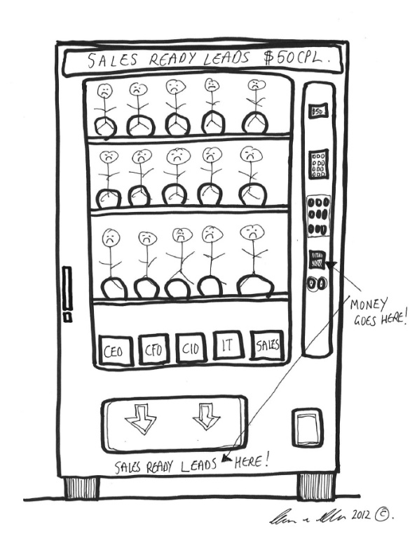
The main function of a vending machine is to allow a customer to buy product(s) from the machine (candy, chocolate, soda, juice, etc.). When the customer wants to buy some of the products offered by the vending machine, he/she inserts money into the machine, selects one or more products, and the machine dispenses the selected product(s) to the customer within a time that doesn't exceed 20 seconds. The products should cost less than or equal the amount of money the customer puts in the machine. The vending machine shall dispense change in case the amount of inserted money is more than the selected product cost. Also, the vending machine needs to be restocked when it runs out of certain products. In addition, only an authorized person (a collector) shall collect money from the vending machine.

- Write down three functional requirements of the system.
- Write down two non-functional requirements of the system.

